|  |
| --- |
| **e-Learning Pre-Semester Checklist** |

|  |  |
| --- | --- |
| **Checklist:**  At least *fourteen* days prior to the start of the course, please make sure to review and update the following items in Canvas and Simple Syllabus: | |
| **Canvas:**   Course Home   Activity Availability Dates & Due Dates   Complete Honorlock Proctoring Setup   Quiz/Exam Settings   Review Course Materials   Publish Your Canvas Course | **Simple Syllabus:**   Faculty Information (Bio required)   Course Overview (required)   Faculty Policies (required)   Adjust Course Schedule   Course Learning Activities and Due Date Summary (in Canvas)   Publish Your Syllabus (Required) |

# Photo showing screenshot of Faculty Information on Canvas Homepage.Canvas:

# 

# Course Home

Update your instructor information located on the course Home page. Use the template provided.

**To Edit.** To edit the Home page, click on the “Edit” button located on the top of the page. Scroll down until you see “Your Instructor”. Only edit the text next to Name, Phone, E‐mail, and Semester. Once you are finished, click “Save”. Remember to direct students only to your Canvas Inbox for communication.

***50% of Courses have a redesigned Homepage as of Fall 2023. If your course does not have this section. Do not add it or alter the homepage in anyway. ***

# Activity Availability Dates & Due Dates

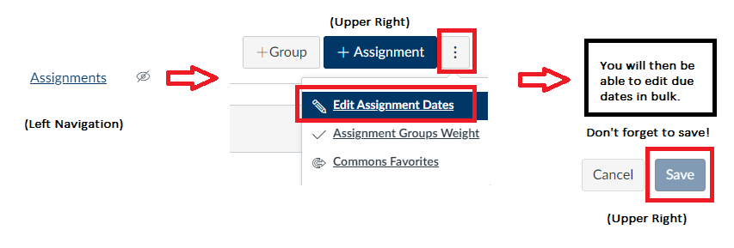**To Set:** Navigate to “Assignments” located in the left navigation in Canvas. Then click the three stacked dots in the upper right corner. This will enable a drop-down list. Please select “Edit Assignment Dates.” You will see a list of assignments that you can edit in bulk. Please add a “Due At”, “Available From”, and Available Until” date for each assignment. Remember to click “save” in the upper right corner when you are finished.

Due dates must be set up in line with the Weekly Breakdown of Modules in the syllabus. The Get Started Module: Orientation Quiz must be set up with both the “until” date and the Due date set to the end of the term. This will allow all students the opportunity to complete the Orientation Quiz.

**Online students have access to the Canvas course five days prior to the term start to complete the Readiness Activities which includes the Orientation Quiz.** Therefore, do not set an “available from” date for the Orientation Quiz.

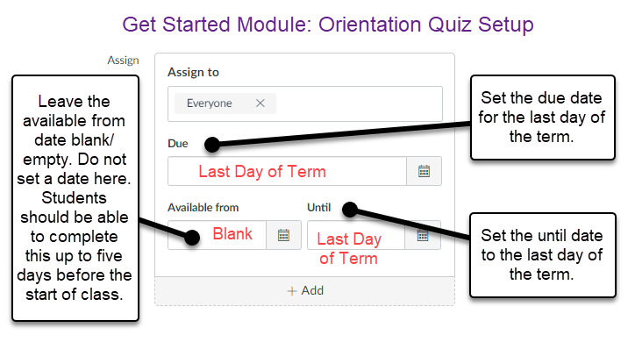

# Complete Honorlock Proctoring Setup

All courses use Honorlock Proctoring in e-Learning. Instructors are responsible for ensuring that Honorlock is setup for their course. To set up Canvas Proctoring follow these steps:

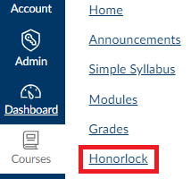 **Step 1:** Navigate to “Honorlock” in the left navigation panel.

**Step 2:** Copy the Honorlock settings into your course by clicking the blue “Copy Honorlock Exam Settings button.

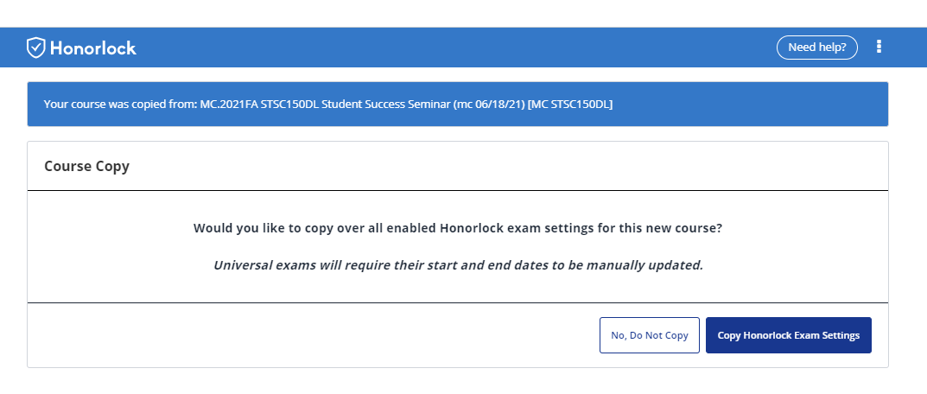

**Step 3:** Click the blue “Ok” button to confirm the copy.

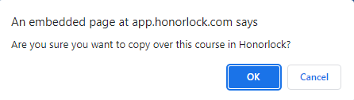

**Step 4:** All Honorlock setting will come over with the copy for *Canvas Proctored assessments*. Check that the Honorlock Assessments listed in your Simple Syllabus are enabled for proctoring in your course. If the Assessments in the syllabus and the enabled Honorlock Assessments in Canvas course do not match, email [elearninghelp@ocean.edu](mailto:elearninghelp@ocean.edu) to submit a ticket. Instructors are **not** permitted to add, alter, or adjust the assessments being proctored or the proctoring settings.

**Third-Party Proctoring** courses will require additional setup from the Faculty. Please refer to the help text embedded **in your Simple Syllabus** and follow the instructions to complete the setup of Honorlock in your course if it is a Third-Party course (ACCT-121, EDUC-178, ENGR-221, ENGR-222, HEHP-225, MATH-023, MATH-156, MATH-161, MATH-265, MATH-266, MATH-270).

# Quiz/Exam Settings

For each course quiz/exam, as the instructor, you have the option to allow students to see their responses and view the correct answers. To edit these settings, please follow these steps,

**Step 1.** Click on Modules, located on the course navigation.

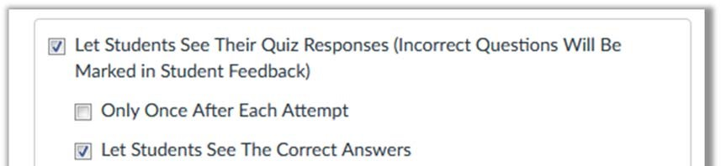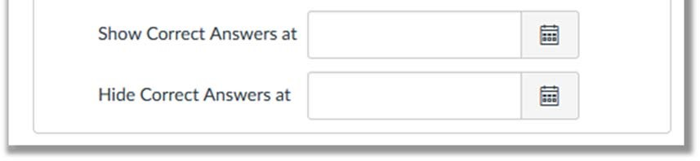

**Step 2.** Click on the appropriate quiz/exam.

**Step 3.** Select “Edit”, located on the top of the page.

**Step 4.** Under Options, please check the appropriate settings based on your course policies.

*\*Instructors have the option to adjust these settings based on their course. If you feel that students should not be able to view their answers, you may keep the correct answers hidden.*

# Review Course Materials

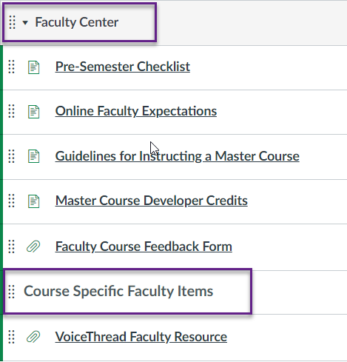Please take the time to ensure that all content items are present in the course. If the course schedule mentions an item that is not located in one of the modules, please notify the eLearning Department by emailing [elearninghelp@ocean.edu](mailto:elearninghelp@ocean.edu). It is also important that you report any broken videos or links to elearninghelp as well.

*This includes reviewing the* ***“Faculty Center Module”*** *in canvas or any course specific set up information or class resources. This is especially applicable to courses that have third party integrations, lab kits, or those using VoiceThread.*

# Publish Your Canvas Course

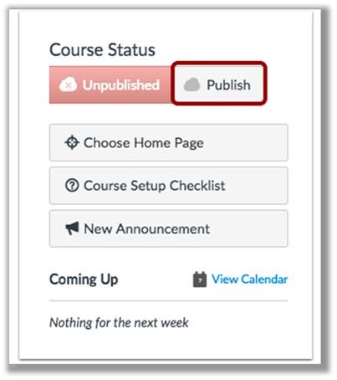

Please make sure to publish your course 14 days prior to the session start date. If you fail to Publish your course, students will not be able to access the course or the course content.

**Step 1.** Open your course and view the Course Home

Page. In the Sidebar, click the *Publish* button.

**Step 2.** Ensure that all module content is published. This can be done by going to each Module in the course and clicking on the cloud icon. If the icon displays “green”, the content is published.

# Simple Syllabus:

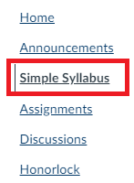Access: Click “Simple Syllabus” in the Canvas left navigation to access your syllabi.

Email: [support@simplesyllabus.com](mailto:support@simplesyllabus.com)

Searchable [Knowledgebase](https://simplesyllabus.zendesk.com/hc/en-us)

Please note, you can not publish your syllabus without adding content to the required sections. To save your changes, see directions below about “Publishing Syllabi”

Access Simple Syllabus from the left navigation in your Canvas Course.

# Faculty Information (Bio Required)

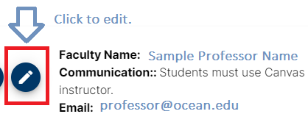In Simple Syllabus you will notice your name and email are automatically populated here.

In this section, adding your Faculty Bio is required. Share information about your educational background, academic accomplishments, research interest, teaching pedagogy, and a photo (photo is optional). Please refrain from sharing information this is too personal, political or expresses religious beliefs.

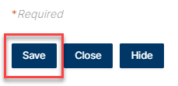You can utilize this section to add optional office hours, phone number, or additional information by clicking the pencil in the blue circle. You are also able to edit your Faculty Name if you prefer. When you are finished editing your Faculty Information, make sure to click “save.”

# Course Overview (required)

Add an overview of the course which should include the number of learning activities such as discussions, assignments, assessments, labs and other applicable information regarding the course. In the past you may have posted an announcement providing your perspective of the “broad overview” of the course. Please note, Simple Syllabus is HTML Rich Text enabled and you have the ability to add hyperlinks and embed videos. **Do not paste content found elsewhere in the syllabus in this section.**

# Faculty Policies (required)

Update the Faculty Policies section in Simple Syllabus.

**Step 1.** Click on Simple Syllabus, located on the course navigation.

**Step 2.** In Simple Syllabus, scroll to the Faculty Policies Section and input information. This content component is rich text enabled.

# Student Supplemental Materials and Resources (optional)

This optional area is reserved for Faculty to input any additional resources you want to make students aware of to supplement the course content.

# Adjust Course Schedule

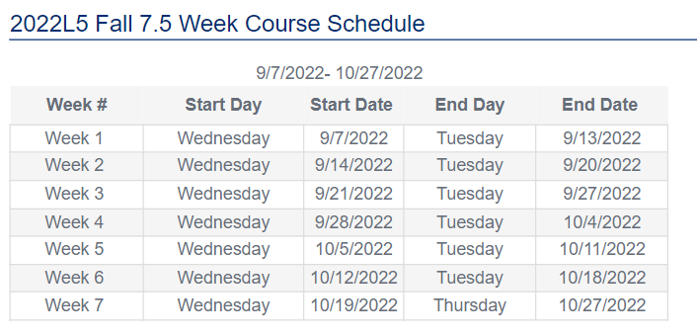The suggested Course Schedule will automatically be populated into Simple Syllabus for you. However, this section is editable by the Faculty. With this feature, we wanted to provide increased flexibility for you to set due dates that align with the start day of the term. Each term you will be provided a *suggested* Instructional Calendar for your planning purposes. However, if you choose not to use the suggested weekly outline, you *are* able to adjust the Course Schedule in Simple Syllabus to reflect your assignment due dates accordingly. We hope you and your students benefit from this increased flexibility to accommodate the varying start day of our terms.

Access the Instructional Calendar in the [e-Break Room here.](https://oceancc.sharepoint.com/:x:/s/elearningresources/EU-rYlzZhfNMq_QyqHvL9RcBKR9HSnaqjTUCuIAWkH6gUg?e=9jkbDz)

# Course Learning Activities and Due Date Summary (in Canvas)

The due dates section of Simple Syllabus is a data pull directly from Canvas. Instructors will still set and adjust due dates in **Canvas**. They will be reflected in the syllabus which will refresh each afternoon.

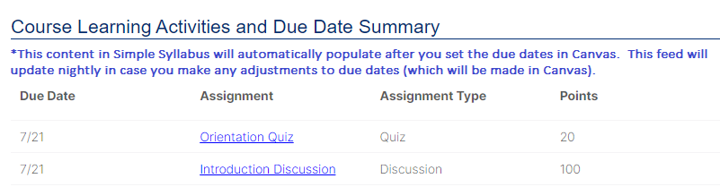

# Publish Your Syllabus (Required)

Screenshot of Publish Syllabus button.Once you have completed the required sections (Faculty Bio, Course Overview, and Faculty Policies) and added information into the two optional sections if you choose, you are ready to publish your syllabus. Publishing the syllabus is required and makes it visible to students. Once published, students will be able to view the syllabus both inside Canvas as well as access it from their student dashboard or the Syllabus Library. All syllabi must be published by the course publication deadline which applies to both publishing your Canvas Course as well as your Simple Syllabus.

To publish your syllabus, click the floating blue “Publish Syllabus” button at the bottom of the screen. You must publish both your Canvas Course *and* Syllabus by the communicated deadline.

|  |  |
| --- | --- |
| C:\Users\cbrittain\AppData\Local\Microsoft\Windows\INetCache\Content.MSO\C710316B.tmp | C:\Users\cbrittain\AppData\Local\Microsoft\Windows\INetCache\Content.MSO\A7F479B1.tmp |
| **Technical Questions** | **Academic Questions** |
| To report canvas, technical, or design-related issues in your course, please contact our Tech team at [eLearningHelp@ocean.edu](mailto:eLearningHelp@ocean.edu). | For non-technical and academic questions, we will direct you to the appropriate person on our team when you email [eLearningAdmin@ocean.edu](mailto:eLearningAdmin@ocean.edu). |