# Grade Reporting, e-Learning

***-- Every student on your roster must be issued a final grade. --***

## Complete these steps in order to officially submit your grades:

1. Be sure you are ready to provide final grades to the entire class. Although the system allows partial grading to be submitted, course grading will not be considered complete until **all** grades are entered.   Once you enter grades, they are official, and will be available to the students to view.
2. First, **log into**[**Ocean Connect**](https://connect.ocean.edu/Connect/Default.aspx). Select [Self Service](https://studentview-02.ocean.edu/Student/Student/Faculty) for Faculty and Staff.



1. In Self Service click “Faculty.”
2. From the faculty screen, select the correct section.
3. Then navigate to Grading >> Final Grade

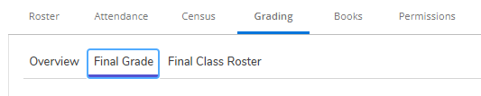

* Using the drop-down list, choose the grades for each student that corresponds to their grade per the syllabus. See the examples below.

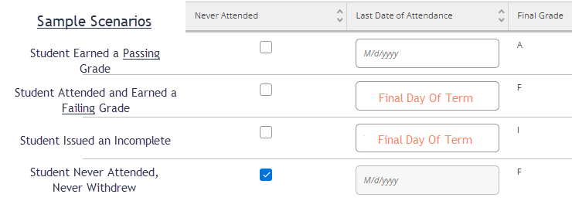

***Sample Explanations:***

* *Students who did not attend and did not withdraw still need a final grade. They should have a check mark next to “Never Attended” and they should be awarded a final grade of “F.”* 
  + The Never Attended button will be available and if you didn’t check it off when your Final Class List was submitted, you can check it off now, while submitting your final grades.
* *If the student failed the class, they should be awarded an “F” and the Last Day of Attendance should be the final day of the semester.*
* *If you are awarding an I [Incomplete] grade, you also need to input a last day of attendance as the final day of the semester.*

1. Verify that your grades are correct. Once **every student has a grade**, and you’ve looked it over for accuracy, select “Post Grades” in the upper right corner. Once submitted, these grades can not be changed via Self-Service. If you feel you may have submitted a grade in error, contact the Academic Administrator at [elearningadmin@ocean.edu](mailto:elearningadmin@ocean.edu) to submit a [Change of Grade Form](https://media.ocean.edu/files/elearning/Academics/Change%20of%20Grade%20Instructions%20&%20Procedures.pdf).  You cannot change verified grades online. You can also not issue an incomplete once grades have been submitted.
2. If you have a student in your class who is not listed on this roster, the student was either dropped or withdrawn. Contact Registration and Records with questions about these students. Email [registrar@ocean.edu](mailto:registrar@ocean.edu) or call [732-255-0304](http://tel:732-255-0304/).
3. Once grading is completed for all sections you are teaching, log out.

Grades should be submitted as soon as possible after the conclusion of the course.  **The final deadline for grade submission is 72 hours from the last day of the term for Full Time tenured faculty and 48 hours for all other faculty.**  Your cooperation with this deadline is **essential,** and much appreciated!

*\*\* Submitted grades should match the letter/numerical grade equivalent from your syllabus\*\**

|  |  |  |  |
| --- | --- | --- | --- |
| **Grade** | **Quality Points** | **Numerical Equivalent** | **Grade Interpretation** |
| **A** | 4.0 | 90-100 | Excellent |
| **B+** | 3.5 | 87-89 | Very Good |
| **B** | 3.0 | 80-86 | Good |
| **C+** | 2.5 | 77-79 | Above average |
| **C** | 2.0 | 70-76 | Average |
| **D** | 1.0 | 60-69 | Below average |
| **F** | 0.0 | 59 & below | Failure (Last date of attendance must be entered.) |
| **I** | 0.0 |  | Incomplete: Refer to [Policy # 5154](https://www.ocean.edu/wp-content/uploads/2021/04/5154-Policy-3.25.21.pdf) to see eligibility for an Incomplete. Once the student has completed the work, you must submit a [Change of Grade Form](https://media.ocean.edu/files/elearning/Academics/Change%20of%20Grade%20Instructions%20&%20Procedures.pdf), converting the “I” to the appropriate earned grade.  Students have 30 days **beyond the semester**, after which all “I” grades will automatically become “F.” |
| **R** |  |  | Audit – Should only be assigned if the student initially registered to audit the course. |

**You cannot issue a “W” at this point.**