

OCC Guidelines and Standards for Online Learning

*Version 2.3*

*2020 Calendar Year*

Property of Ocean County College, Department of e‐Learning



**Table of Contents**

[Welcome from the e-Learning Department! 3](#_Toc32578865)

[OCC Civility Statement 4](#_Toc32578866)

[Appointment Process & Qualifications 5](#_Toc32578867)

[Online Instructor “Pool” Status Explained 7](#_Toc32578868)

[Teaching Assignment Process Explained 8](#_Toc32578869)

[Email Addresses Explained 9](#_Toc32578870)

[Ocean Connect & Online Course Access Explained 10](#_Toc32578871)

[E‐Learning Training Courses 1](#_Toc32578872)1

[Presemester Checklist 13](#_Toc32578873)

[Online Instructor Evaluative Criteria 17](#_Toc32578879)

[Federal Financial Aid Attendance Policy 19](#_Toc32578880)

[Dropping, Adding, and Withdrawing from Online Courses 20](#_Toc32578881)

[How to Obtain Last Date of Attendance 22](#_Toc32578882)

[Final Class Roster Procedure 25](#_Toc32578883)

[Final Grade Submission Procedure 26](#_Toc32578884)

[Teaching Practices within Master Courses 28](#_Toc32578885)

[E‐Learning Assessment at OCC 30](#_Toc32578886)

[Distance Learning (DL) Student Issue Resolution Process 31](#_Toc32578887)

[Online Instructor Support 32](#_Toc32578888)

[E‐Learning Contact Information 33](#_Toc32578889)

[Employment Contracts 34](#_Toc32578890)

[Course Overload Authorization Form (For Instructors) 35](#_Toc32578891)

[Change of Grade Form 36](#_Toc32578892)

[Policy 5180: Cheating and Plagiarism 38](#_Toc32578894)

Evaluative Process for e-Learning Instructors……………………………………………………..………………………………………….41

Process for Addressing Identified Deficiencies in Online Instruction………………………………………………………..…….43

Addendum…………………………………………………………………………………………………………………………………..…………………44



# Welcome from the e-Learning Department!

Welcome!

Is there anything as thrilling as a new semester? One of the great privileges we enjoy as instructors is the anticipation and excitement that accompanies the commencement of a new term. For e‐Learning instructors our opportunities for innovation, invention, and interaction are nearly limitless. Our classes are populated by students from around the world and our lessons work to bring diverse groups together in ways that brick‐and‐mortar classes cannot manage. The start of a new term is a very exciting moment for us all!

To help faculty make the most of this opportunity we have developed this guide. The hope of this guide is to anticipate questions that arise about our policies, procedures, and expectations for e‐Learning courses and to provide clear and concise answers to those questions. A primary goal within this document is to deliver tools for instructors to create effective, vigorous online classes that promote student success and academic standards.

An additional goal of e‐Learning is to create environments that provide students with consistency and predictability across courses. Students perform best, and get the most value from courses, when they have a robust understanding of what is required of them and can use the tools provided to them with ease. This is one of the keys to affording students the best likelihood of success and it is accomplished through the use reasoned procedures and policies. Students that can transport knowledge from one course to the next, or easily recognize the structure of a course, enjoy greater success in our courses.

Of course, consistency in procedures and adherence to stated course objectives also helps the instructor manage a course. We hope that you will share the benefit of your ideas with us for changes in the processes in e‐Learning so that we can all profit from the wealth of knowledge teaching in the e‐ Learning area provides. Even the most experienced instructors will find benefit in reading this Guide.

Please take time to review the Guide’s materials, explanation of policies and procedures, and let us know what else we can do to give our e‐Learning students the best environment for success in the business!

Thank you and get ready for the excitement that is coming in the new semester!



# OCC Civility Statement

Ocean County College defines civility primarily as the demonstration of respect for others, basic courtesy, reciprocity (treating others as we wish to be treated), and behaviors that create a positive environment in which to learn and to work. The Trustees of the College and the College Administration set the tone for civil behavior through their professional conduct and through their leadership of the institution. All members of the college community create a positive environment characterized by considerate and principled conduct.

While no civility statement can guarantee considerate and principled conduct, the values set forth herewith represent institutional ideals and should serve as guide posts:

1. Respect for the work of all persons
2. Courteous discourse (oral, verbal, non‐verbal and electronic)
3. Honest interactions and utterances
4. Fair and just treatment
5. Integrity and keeping promises
6. Commitment to the community college philosophy; Access, transfer, career preparation, workforce development, partnering, and community outreach.
7. Open professional communications
8. Diversity, professional communications
9. Free expression of views without meanness or a desire to do harm.
10. Tolerance of differing points of view
11. Zero tolerance for any forms of cyber stalking, cyber bullying, or cyber sexual harassment (see the Attorney General’s letter)
12. A culture of honor that enhances our student’s ethical and moral development and clearly communicates and consistently adheres to the definitions of and sanctions for academic dishonesty.



# Appointment Process & Qualifications

#### Appointment Process – Distance Learning (DL)

All faculty members who wish to teach courses through the e‐Learning Program will be selected by the Dean and Assistant Dean of the e‐Learning Faculty in cooperation with the deans of the four academic schools in accordance with College Policy. However, selection and/or training in online course instruction does not constitute a guarantee of scheduling. When hiring or adding new instructors to teach courses in the online modality, the Dean and Assistant Dean of e-Learning utilize policies 3111A Qualifications for Full-time 10 month Faculty and College Lecturers, 3111B Qualifications for Adjunct Faculty and Teachers.

The Dean and Assistant Dean of the e‐Learning Faculty will be responsible for evaluating teaching performance, completion of the Student Evaluation Process and ensuring compliance with all College and Academic Affairs responsibilities.

Failure to achieve excellence in any of the above will result in the faculty members being denied teaching assignments in the e‐Learning Program.

#### Qualifications

Full Time Faculty and College Lecturers:

* Educational Criteria:
* A Master’s degree from a regionally accredited institution of higher education in the field of specialization for which he/she is making application; or
* A Master’s degree from a regionally accredited institution of higher education in a different field from the one for which the candidate is making application plus 18 graduate credits in the field for which he/she is making application; or
* A Master’s degree from a regionally accredited institution of higher education in a different field from the one for which the candidate is making application plus at least five years of related professional field experience and/or certification/licensure in the field for which he/she is making application.
* Experiential Requirements:
  + Two years of successful full-time teaching experience in the field for which he/she is making application or at least six semesters of part-time teaching experience at the college level; or
  + At least five years of related professional experience and/or certification/licensure in the field for which he/she is making application may be substituted in lieu of teaching experience with the approval of the Provost and President (or designee).
* Successful teaching experience with web‐enhanced or on‐line courses with accompanying favorable student evaluations, classroom observations, and administrative evaluations.
* Successful completion of OCC’s Online/Hybrid Instructor Training Certificate Course may be utilized if there is a lack of web‐enhanced or on‐line teaching experience.

Adjunct Faculty:

* Educational Criteria:
  + A master’s degree in the discipline for which he/she is making application; or
* A master’s degree in a different discipline for which the candidate is making application plus 18 graduate credits in the discipline for which he/she is making application; or
* A bachelor’s degree in the discipline and at least five years of full-time teaching or directly related professional field experience and certification or licensure in the field of specialization.
* Experiential Requirements:
* Prior experience teaching at the high school or college level; or experience as a trainer or in conducting group presentations. Part-time experience will be pro-rated and applied to the five-year requirement at the discretion of the dean.
* Experience teaching completely online.
* Canvas experience preferred.
* Successful completion of OCC’s Online Instructor Training Certificate Course.
* Personal Characteristics:
  + Effective communicator
  + Student centered
  + Creative & Dynamic
  + Technologically adept



# Online Instructor “Pool” Status Explained

The e-Learning Department maintains a pool of vetted, qualified, and internally trained instructors to staff the growing demands of online students. Once an applicant is hired to serve as an Adjunct Online Instructor and successfully completes the Online Instructor Training (OIT) course, he or she is placed into this “pool” of qualified applicants and can be called up on to teach as needed.

Hiring by OCC as an Adjunct Online Instructor does not guarantee that a teaching assignment will be made. Rather it is an indication that you are eligible to teach for us depending on departmental needs. If you are assigned to teach a course, you would receive a course assignment email, which states the term and course that you are assigned to teach. Timely response to course assignment emails is required in order to retain the course assignment.



# Teaching Assignment Process Explained

Once an instructor is hired, the first step is to take the Online Instructor Training course. Once they successfully pass the course, they are placed into the pool of qualified adjuncts who may be considered for course assignments. New instructors may not be offered an assignment until there is need for additional instructors in the area in which they are qualified.

The e-Learning Academics team gathers information from a myriad of sources when determining teaching assignments. Such sources include but are not limited to:

* + - Faculty qualifications
    - Prior online teaching experience
    - Faculty evaluations
    - Instructor completion of key semester tasks
    - Data analytics available in the college’s current LMS

A draft of the assignments for a given semester is developed, months in advance of the semester. The e-Learning Academics team collaborates with the Deans of each academic school to provide course assignments to instructors effectively, appropriately, and with the overall needs of the institution in mind. Final course assignments are at the discretion of the Dean of e-Learning.

In order to maintain e-Learning’s pool of qualified instructors, and to support learning diversity in every area, the number of courses assigned to an instructor may vary by semester. This allows for assignment of courses to an array of qualified instructors. Also, students are not reliant on a single instructor for a particular discipline or course. The e-Learning Academics team reserves the right to assign courses in the manner that best fits the needs of the college.

Once the final assignments are made, the Academic Administrator for e-Learning sends Confirmation Emails to each instructor informing them of the assignment and asking that they accept or decline the assignment in a response email to the Academic Administrator for e-Learning. An additional requirement within the course assignment email is that the instructor acknowledges and accepts the Online Instructor Evaluative Criteria, which are detailed in the email. Instructors that fail to respond to the course assignment email by the stated deadline may be removed from a scheduled course and the course reassigned to another instructor.

**Note:** Newly hired or trained instructors are typically given only one online course assignment in their first semester teaching online.



# Email Addresses Explained

As an Online Instructor at Ocean County College, you will have two (2) email accounts.

[JSmith@ocean.edu](mailto:JSmith@ocean.edu)

The “@ocean.edu” address is your primary email address.

##### All official emails from the College and e‐Learning will be sent to this address.

To access your email account, please use this link: https://mail.ocean.edu

**Username:** first initial last [name@ocean.edu](mailto:name@ocean.edu) **Example:** [js](mailto:jsmith@ocean.edu)[mith@ocean.edu](mailto:mith@ocean.edu) **Password:** 7-Digit Employee ID

#### Class Email

Ocean Online utilizes Canvas as the Learning Management System for all online courses. Each class has a compartmentalized email system built right into the Canvas system. All emails with students, about a particular class, should be contained in this area. Instructors should not routinely utilize the @ocean.edu address to communicate with students about classes.

Online course instructors are encouraged to link Canvas e-mail notifications to their “ocean.edu” e-mail to assure continuity of communication. The below steps will walk you through how to setup your e-mail settings within Canvas.

1. Log in to Canvas.
2. Click on “Account”, located on the Global Navigation.
3. Select “Settings.”
4. Under “Ways to Contact”, select “+ Email Addresses”, enter in your “ocean.edu” e-mail address.



# Ocean Connect & Online Course Access Explained

Accessing your online class at Ocean Online requires you to log in through Ocean Connect.

Your Ocean Connect login information is the same username and password for your Office 365 account.

To access Ocean Connect, visit [www.ocean.edu](http://www.ocean.edu/) and click on **Ocean Connect**, located under MY OCEAN. (Note: you may want to bookmark this page for future reference).

Log in by entering your username and password into the fields on the right hand side.

Once you are logged in, you will see links for “My Courses,” “OCC Email” and “WebAdvisor for Faculty.” All of these are important links and constitute the bulk of your needs while teaching for OCC Online.

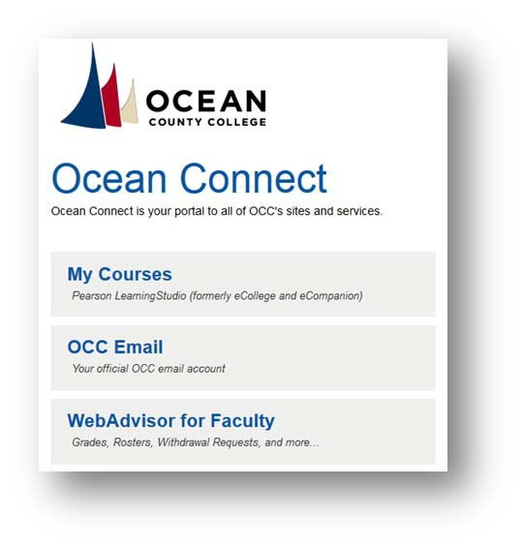

Clicking on “My Courses” will take you to the Canvas Platform which is OCC’s learning management system.

 Please be sure to disable your pop‐up blocker or else the new window containing the learning management system may not be able to open.



# E‐Learning Training Courses

#### General

The e‐Learning Department at Ocean County College offers the below training courses for Distance Learning (DL) faculty. These courses are prerequisites to either teach online or to develop online master courses. The following represents current training offerings:

##### Online Instructor Training Course

All OCC online instructors are required to complete the Online Instructor Training (OIT) course prior to teaching online. This course, taken via Canvas, explains how to navigate the LMS, prepare an online course, teach according to best practices, and comply with required departmental and college-level rules. The OIT course contains four primary modules that are assessed by end-of-module quizzes. Trainees may not proceed to upcoming modules until they pass each quiz and sign an acknowledgment that they have read and understood the material within the module. With each acknowledgment, instructors pledge to adhere to related policies and procedures if they are assigned to teach an online course at the college. The OIT course is offered at various times throughout the year and is self-paced. Instructors are not eligible for an online course assignment until they have successfully completed the OIT and earned a certificate.

##### Master Course Developer Training Course

All instructors who receive an assignment to work on master course development must first complete this course. This professional training course is designed for faculty who wish to design online master courses for the Ocean County College e-Learning Department. Participants in this course will gain knowledge and skills in course planning, design and development, including creating content, assessments, and other interactive activities that create a meaningful online learning experience. Participants who successfully complete this course will be able to:

* Identify the Master Course Development Process, including the steps to design and complete an Online Master Course.
* Apply the Master Course Template when developing content modules.
* Construct a course Syllabus, Course Schedule, Reading Schedule, and Content Module using Canvas.
* Describe the Master Course quality Assurance check, and develop final course documents.

#### 

#### How do I get started?

Following your official hiring and account creation, you will be assigned the next available session of the training course if you were hired to teach online (DL). If you are interested in other training opportunities, please contact the Dean of e‐Learning. If you have any questions regarding training, please contact Rachel Doss-Block, Associate Director of e-Learning & Learning Enterprises, [rachel\_doss@ocean.edu](mailto:rachel_doss@ocean.edu), or 732-255-0400 x7999.

**Certificate**

Once you have successfully completed a training course, you will be issued a certificate of completion and your Human Resource personnel file will be updated.

# C:\Users\rachel_doss\Desktop\Canvas Logos\OCC-White.pngPresemester Checklist

## Prior to teaching a DL course, please make sure to update the following items:

1. **Course Home**

Update your instructor information located on the course Home page. Use the template provided.

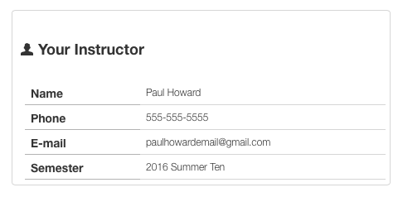

**To Edit.** To edit the Home page, click on the “Edit” button located on the top of the page. Scroll down until you see “Your Instructor”. Only edit the text next to Name, Phone, E-mail, and Semester. Once you are finished, click “Save”.

# Activity Availability Dates & Due Dates

**Step 1.** Review the weekly breakdown of the course schedule, which is located under the Get Started Module. E.g. Week 1 covers Get Started, and Module 1; Week 2 covers Module 2 and so on.

**Step 2.** Go to Syllabus, located on the Course Navigation. Under “Assignment Summary”, you will see a list of assignments. To add an Availability Date and Due Date, right click on the item, open link in new tab, EDIT, scroll down to Assign, and enter in an Availability Date and Due Date. You will need to do this for each course item.

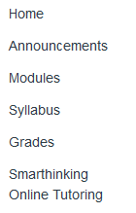

* 1. Readiness Quiz and Introduction Discussion should be due on the first week;

#### Assignments

If your course assignments require students to submit through Turnitin, please follow these instructions on how to setup the Turnitin assignment.

**Step 1.** Go to the module assignment, right click, and open in a new tab.

**Step 2.** Click on “Edit Assignment Settings”.

**Step 3.** Scroll to “Submission Type”, select “Online”.

**Step 4.** Click the option for “File Uploads” under “Online Entry Options”.

**Step 5.** Scroll down to “Plagarism Review” options, select “Turnitin” from the dropdown.

**Step 6.** Ensure that all three boxes under “Compare submissions against” are checked.

**Step 7.** Add in an assignment Due Date on the bottom of the page. Click “Save”.

*\*If you need assistance, please contact* [*elearninghelp@ocean.edu*](mailto:elearninghelp@ocean.edu)

#### Quiz/Exam Settings

For each course quiz/exam, as the instructor, you have the option to allow students to see their responses and view the correct answers. To edit these settings, please follow these steps,

**Step 1.** Click on Modules, located on the course navigation.

**Step 2.** Click on the appropriate quiz/exam.

**Step 3.** Select “Edit”, located on the top of the page.

**Step 4.** Under Options, please check the appropriate settings based on your course policies.

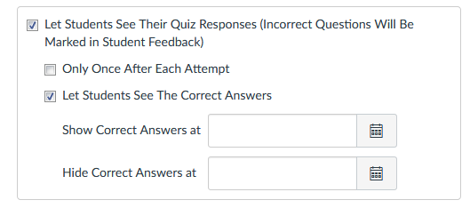

*\*Instructors have the option to adjust these settings based on their course. If you feel that students should not be able to view their answers, you may keep The Correct Answers hidden.*

**Instructor Policies**

Update the Instructor Policies section in the Syllabus.

**Step 1.** Click on Modules, located on the course navigation.

**Step 2.** Select Syllabus, located under the Get Started Module.

**Step 3.** Click on “Edit”, located on the top of the page.

**Step 4.** Edit the Instructor Policies section, click “Save”.

**Instructor Bio**

Share some information about yourself to your students. Here are some recommended items.

* Educational Background
* Academic Accomplishments
* Research Interests
* Teaching Pedagogy

Not recommended: overly personal non-related information; personal preferences outside the discipline (for example: political, social, and religious beliefs)

# 

# Review Course Materials

Please take the time to ensure that all content items are present in the course. If the course schedule mentions an item that is not located in one of the modules, please notify the eLearning Department. It is also important that you report any broken videos or links.

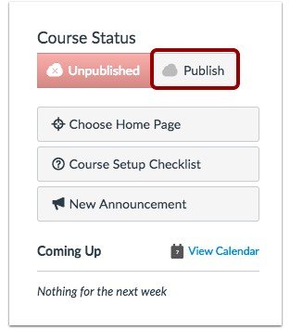

# 

# Publish Your Course

Please make sure to Publish your course prior to the semester start date. If you fail to Publish your course, students will not be able to access the course or the course content.

**Step 1.** Open your course and view the Course Home Page. In the Sidebar, click the *Publish* button.

**Step 2.** Ensure that all module content is published. This can be done by going to each Module in the course and clicking on the cloud icon. If the icon displays “green”, the content is published.

## Important:

* Instructors may only update the Instructor Policies section in the Syllabus. If you have any questions or concerns regarding the information found in the Syllabus, please contact the eLearning Department.
* Please DO NOT remove or modify course content templates or colors in your course(s). Course templates and colors were approved by the eLearning Department to ensure that all online courses have the same user experience.
* Please DO NOT remove or modify the picture slideshow located on the course Home Page. If the slideshow is accidentally deleted, please contact the eLearning Department.



# Online Instructor Evaluative Criteria

**Before**

*At least ten days prior to the term start date, please address the following:*

* Ensure that content, links, and integrations are working in all modules and become well-versed in all relevant integrated tools (ex: Turnitin, WebAssign, MindTap, MyLabs, RosettaStone, etc.).
* Do not remove any course content or integrated tools from the copied master course shell. Instructors are encouraged to add supplemental resources and announcements.
* Review, update, and adhere to course schedules for the relevant term of your class and remove terms that do not apply.
* Publish your course with due dates on all graded items.
* Update home page with your name and contact information, including your OCC email address.
* Provide an Instructor Bio (under Resources in the Get Started module);
* Add a Welcome Announcement that directs students to the course goals and objectives and requires students to complete the Get Started Module by the attendance census date. Please specify the census date for your term, and alert students that they will be automatically dropped from the class, per OCC policy, if they do not complete a quiz, assignment, or discussion post by census.
* Schedule an activity, such as the Readiness Quiz, to be due by the census date.

**During**

*During the semester, instructors shall:*

* For students who need ADA accommodations, provide immediate accommodation, per instructions from Disability Services.
* Maintain student privacy at all times, in accordance with FERPA regulations. Do not discuss grades or confidential student information with anyone other than that student.
* Log into the course daily, Monday through Friday.
* Electronically acknowledge and respond to all student questions/emails within 24-48 hours.
* Grade all assignments within five working days.
* Participate in and monitor discussion boards at each login.
* Monitor student attendance, which is measured by active participation (ex: submission of an assignment, discussion, or quiz).
* All written communication with students must occur through the Canvas email tool.
* Provide individualized feedback and use rubrics in the evaluation of assignments to ensure that students understand their strengths and deficiencies.
* Open and read the Turnitin similarity report for all homework submissions, and penalize plagiarism appropriately. Do not make decisions solely on Turnitin scores.
* Report cases of academic dishonesty to eLearning Academics to provide students with an opportunity to appeal, per Procedure 5180 on Cheating and Plagiarism.
* Check Canvas Analytics and send follow-up with private emails to “at risk” students with an offer of assistance.
* Check the Instructor Insight report for your class to gauge your alignment with expectations.
* In the event of an instructor absence, notify students and e-Learning Academics in advance.

**End**

*Of semester, instructors shall:*

* Encourage students to complete the Online Course Evaluation.
* Ensure that grading is complete and grades from integrated tools have been transferred to Canvas.
  + Final grades that are submitted must match the Grading Scale in the Syllabus. For example, if a student earns a 92, they earned an A grade.
* Submit grades by the required deadline:
  + Grades are officially due depending on the collective negotiation agreement for your position. For Adjunct Instructors, Part-Time Teachers, and Administrators, grades are due 48 hours after the last day of class. For Full time Faculty Members and College Lecturers, grades are due 72 hours after the last day of class.
* Manage any incomplete grade requests per the process in the Guidelines and Standards document.
* Complete the Course Feedback Form, located in the Faculty Center Module.

Note: Failure to follow the requirements in this document may result in a reduction or removal of current and/or future course assignments.



# Federal Financial Aid Attendance Policy

#### Distance Learning (DL) Courses

#### Last Date of Attendance Policy for Unofficial Withdrawals:

If a student fails to officially withdraw from a term prior to the withdrawal deadline date of that term, a student’s last date of attendance for the purpose of calculating the return of Federal financial aid funds will be determined as the date at which the student last attended an academically‐related activity (documentation must be available). An academically‐related activity is defined as:

1. Submitting an academic assignment OR
2. Taking an exam/quiz OR
3. Participating in an online class discussion

If no documentation is available to determine a last date of attendance, as per Federal regulations, the Financial Aid office will use the 50 percent point of the term as the date on which the Return of Title IV funds calculation will be based.

The college has a policy (Students Withdrawal General Requirements #5142) which only permits students to withdraw from a course and receive a “W” for that coursework up through the withdrawal deadline date. Students are not permitted to withdraw from courses after the withdrawal deadline.



# Dropping, Adding, and Withdrawing from Online Courses

Please note that if a student is a financial aid student or a veteran, they should consult the appropriate office before dropping courses as a change to their schedule might affect their eligibility.

**Prior to the First Day of the Semester:**

##### Drop

Students may drop a course and will receive a full tuition refund. The course will not appear on their transcript. No permission is required. Exception: Students may not drop developmental English (ENGL 091/ ENGL 095) unless they are dropping all of their courses.

This applies to all Ocean County College students.

##### Add

Students may add a course to their existing schedule as long as they have completed any necessary prerequisite(s) and there is an available seat. Students may do this through Ocean Connect. If they are in developmental courses, they will need to work with their advisor in the HUB to add a course. This will be in effect until all developmental courses are completed.

This applies to all Ocean County College students.

**First Day of the Semester through Attendance Census Date:**

(note: See Academic Calendar for specific dates.)

##### Drop

Students may drop a course without permission and they will receive a 50% tuition refund. If they are adding a course at the same time, there is no loss of the 50% refund. The dropped course will not appear on the transcript. Exception: Students may not drop developmental English (ENGL 091/ ENGL 095) unless they are dropping all of their courses.

##### How to drop:

Prior to the close of business on the attendance census date, fill out an Add/Drop form and take it to the Registration and Records office in the Administration Building on campus.

Students may contact the HUB for assistance at 732-255-0400 ext: 482 or [hub@ocean.edu](mailto:hub@ocean.edu).

**First Day of the Semester through Attendance Census Date:**

##### Add

Students may add a course up until the attendance census date of the semester without seeking consent. They will not be able to do this through Ocean Connect. Any student taking DL courses must contact OCC’s Registration and Records office or the Advising office either by phone or walk‐in. They may also contact the HUB for assistance at 732-255-0400 ext:482 or at [hub@ocean.edu](mailto:hub@ocean.edu) .

Note: While it is permitted for students to register late, up until the Census date, we do not recommend this, as it takes time for a student to actually gain access to their course shell. This may create the inability for a student to participate in their course by the census date, even if they are registered, if the course has not yet showed up for them in Canvas.

**Up To and Including Withdrawal Deadline:**

##### Drop

If a student wishes to submit a withdrawal request, they may do so up until the course withdrawal deadline for the relevant term. To do so, the student must log into WebAdvisor and submit a Student Withdrawal Request. This will automate an email to their professor. The professor should then reach out to the student to confirm this request and then process the withdrawal request once they hear back from the student. If the instructor does not receive a response from the student within a few days, the request must be processed at that time. If an instructor fails to process a withdrawal request within a timely manner (7-10 days maximum), the professor will be required to fill out and scan or fax a paper form to the Registration and Records office to finalize the student’s request to withdraw. Reminder emails are sent by the Academic Administrator for e-Learning to instructors who do not process Student Withdrawal Requests in a timely manner.

**After Withdrawal Deadline until the End of the Semester:**

Students cannot withdraw from a course or change their course section for any reason. Their course and their earned grade will appear on their transcripts.

Students cannot add a course or change their course section for any reason. This applies to all Ocean County College students.



# How to Obtain Last Date of Attendance

Follow these procedures to obtain your student’s Last Date of Attendance:

* 1. Log in to your course.

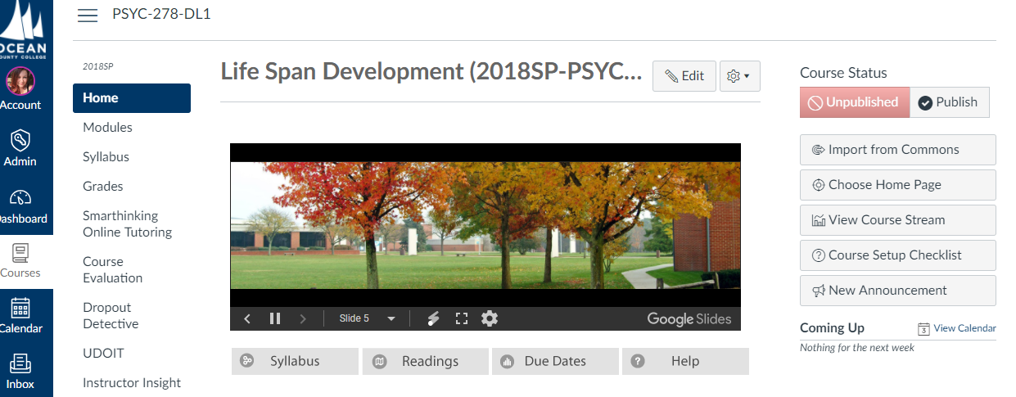

* 1. Click on “View Course Analytics.”

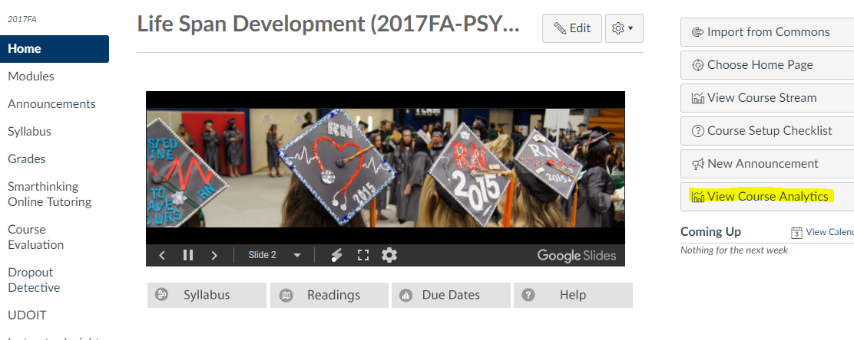

On the Analytics page, scroll to the bottom and select the Student you would like to view.

Click on their name.

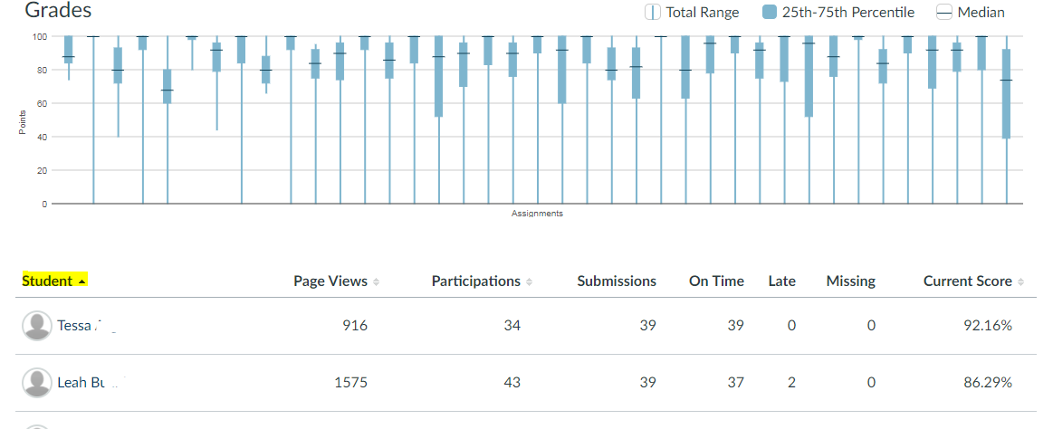

1. In the Student page scroll to the “Submissions” activity line chart, find the last “Green dot or Yellow Triangle” and run your cursor over to get the last date the student has anything but missing (red square).

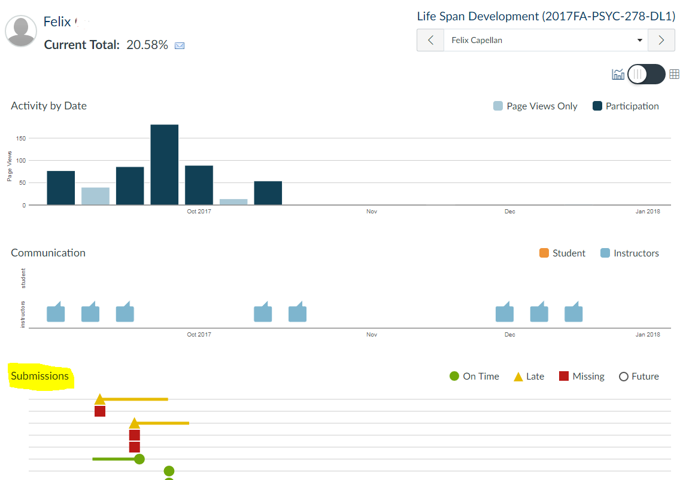

1. Identify the last date the student has anything submitted to the course (a green dot or yellow triangle). This indicates the last day they participated in the class.

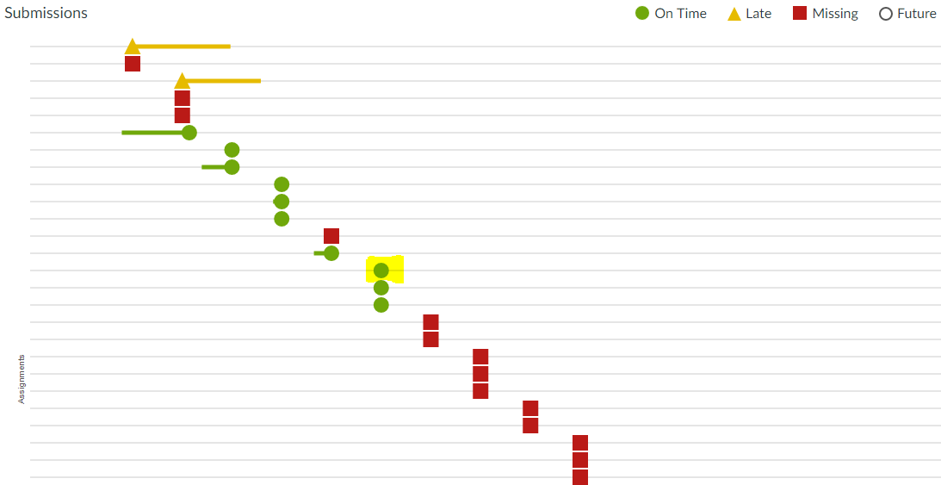



# Final Class Roster Procedure

The Final Class Roster procedure opens for all instructors teaching DL courses the day after the Attendance Census Date for the relevant term. This procedure requires all instructors to submit the Final Class Roster for each online course they are teaching. The Academic Administrator for e-Learning sends out notifications of this requirement each semester, via email, and containing specific instructions that are provided by the Registration department. Here is an overview of the procedure.

#### FCL Procedure

Prior to the Census Date, the Academic Administrator for e-Learning sends the Final Class Roster Memo to all instructors. This is a document containing procedures and a timeline for the FCL procedure and will be sent to the instructors’ OCC email address.

After thoroughly reviewing course analytics, following the attendance census date, instructors should withdraw any students who have not yet participated in the course. Participation in the course includes one of the following actions:

* 1. Submitting an academic assignment OR
  2. Taking an exam OR
  3. Participating in an online class discussion

This action will be done electronically, through WebAdvisor. Specific directions will be provided to instructors each semester on how to complete this required step.

This process is designed to safeguard Federal Aid lending practices and is not intended to be used to evaluate student's potential for academic success in the course. Students should not be dropped for items of academic concern such as poor test scores, underdeveloped discussion board posts, or other academic concerns. If a student has actively participated in any item in the course, he or she may not be dropped from the course for nonparticipation.



# Final Grade Submission Procedure

##### Grades are officially due depending on the collective negotiation agreement for your position.

##### For adjunct instructors, part time teachers, and administrators, grades are due 48 hours following the last day of class. For full time faculty members and college lecturers, grades are due 72 hours following the last day of class.

1. Complete these steps in order to officially submit your grades:
2. Be sure you are ready to provide final grades to an entire class. Partial grading of a class is not possible. Once you enter grades, they are official, and will be available to the students possibly as soon as the next morning.
3. First, log into Ocean Connect. Next, click the WebAdvisor tab at top of the screen. Then, click “Faculty” to the left under the WebAdvisor tab. Since you will already be logged in from your initial login into Ocean Connect, you will not need to log into WebAdvisor separately. [NOTE: Entering grades in your class’s “Gradebook” in Connect does not transfer them to WebAdvisor and is not official grade submission]
4. Click on “Grades” under “Faculty Information.” This will take you directly to the Grading page.
5. Select the semester or term you are looking to grade from the drop down menu, and click “Submit.”
6. Select the course you wish to grade by clicking the circle next to the course, and then clicking “Submit.”
7. Enter each student’s grade using the drop down menu. (If you have a student in your class who is not listed on this roster, the student has either been withdrawn or never registered to begin with. Contact Registration and Records with questions about a particular student.) For students with grades of F, a last date of attendance will need to be entered as well. See the Course Analytics in your course shell for this data.
8. Verify that your grades are correct, and print the web page for your records.
9. Click “Submit.” If there were any students overlooked, you will get a notice of “Incomplete Grading Roster.” Should this happen, enter the missing grades, then click submit again.
10. You will then see the Grading Confirmation Form. Click “OK” to complete submission of grades for that section. You will then be taken back to your list of courses so that you may grade other sections you may be teaching. Once grading is completed, log out. If you feel you may have submitted a grade in error you must submit a Change of Grade Form to the Academic Administrator for e-Learning to change it. You cannot change verified grades online once they have been submitted in WebAdvisor.

Remember you cannot issue a student a “W “ at this point. Grade Choices are:

|  |  |
| --- | --- |
| **A** | **Excellent** |
| **B+** | **Very Good** |
| **B** | **Good** |
| **C+** | **Above** |
| **C** | **Average** |
| **D** | **Below Average** |
| **F** | **Failure** |
| **I** | **Incomplete** |

An Incomplete should be assigned only if the student has approached you for extra time on particular assignments, and you have agreed to allow it. Once the student has completed the work, you must submit a Change of Grade Form, converting the “I” to the appropriate earned grade. There is a deadline of 30 days into the next semester, after which all outstanding “I” grades will become “F” grades. For additional information regarding Incomplete grades, please reference Policy 5154.

**“P” Pass**‐ Rarely, a course runs as pass/fail. This is not an appropriate grade unless the entire course is run as pass/fail.

**“R” Audit**‐Should only be assigned if the student initially registered to audit the course.

Below are pictures of what you will see when navigating online grading:

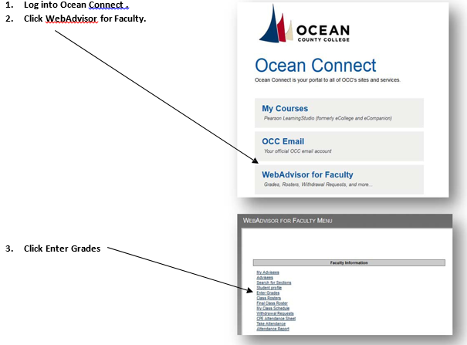

# Teaching Practices within Master Courses

#### Master Courses

##### They are pre-built courses complete with content, activities, requirements, and assessments. OCC utilizes

##### the Master Course format to achieve the following objectives:

##### Ensure alignment between course objectives and course content,

##### Assess and evaluate student performance according to course objectives,

##### Provide consistency across multiple sections of a course,

##### Provide high-quality, vetted & approved content to students.

#### Course Deployment Expectations and Considerations

##### In most cases course shells will be created, populated and deployed to faculty 45 days prior to the start of

##### the term. Course shells for a new term are created manually in the LMS after which the most current

##### iteration of the Master Course Shell is populated into the course.

##### Due to high volume of e-Learning offerings, courses from previous semesters cannot be copied to new

##### semesters. Instructors are encouraged to use the time provided before the semester begins to personalize

##### the course. Any additional material added to a Master Course MUST address one or more of the course

##### objectives listed in the syllabus.

##### Please note, you are unable to delete or modify existing content in the course. If supplemental content

##### is added, it cannot be in the form of graded discussions, assignments, quizzes, or papers. If you notice

##### any discrepancies in the Master Course, please notify the e-Learning Department right away by contacting [elearninghelp@ocean.edu](mailto:elearninghelp@ocean.edu).

##### If you have any suggestions on how the course can be improved, please complete the Course Feedback

##### Form located in the Faculty Center of your course.

#### Instructing

##### Teaching with a Master Course is exactly the same as instructing any other course online. The only

##### difference is that, the content, requirements, and assessments have been professionally developed

##### for you. Your first order of business will be to review the course and familiarize yourself with all of the

##### requirements.

#### Preparing

##### You will need to customize the home page and instructor bio with your own information. The course

##### schedules must be updated with running term actual dates. You will also need to add specific due dates

##### for every graded assessment (assignments, quizzes, discussions, etc.)

#### Adding

##### You should add materials that bring your own experience and expertise to the course. This might include YouTube, web links, Web 2.0, or other multimedia content; literature, articles, or other types of ancillary

##### readings. You should communicate with students freely and use your skills, knowledge and experience

##### to support their learning with any and all means at your disposal. When adding video resources, be sure

##### that closed captioning is available.

#### Removing Course Material

##### The process of developing Master Courses ensures that each and every one of the course components is

##### aligned with one or more course objectives. To maintain the alignment, you are prohibited from deleting

##### any of the original Master Course. You may not delete or change: content, activities, requirements, or

##### assessments; exams, tests, quizzes, projects, papers or other assessable requirements; discussion topics

##### or specific questions. In essence, you are prohibited from altering any of the original Master Course content.

##### To do so would violate the faith and credibility that OCC has placed on the quality of the content and its

##### correlation to course objectives. If you should have any questions or feel that content needs to be updated,

##### please contact [elearninghelp@ocean.edu](mailto:elearninghelp@ocean.edu).



# E‐Learning Assessment at OCC

#### Course Level Assessment

(Policy # 7165)

Each Spring semester, a series of selected courses are required to participate in Course Level Assessment. The e‐Learning Department, in conjunction with appropriate entities on campus, will deploy the assessment instruments to each selected Distance Learning (DL) course.

The e‐Learning Program complies completely with the College’s prescribed Course Level Learning Outcomes Assessment (Policy # 7165). According to the College’s Guidelines all e‐Learning courses will utilized the assessment instruments employed by all the courses of the College. Both traditional (face‐ to‐face and e‐Learning (DL) courses apply common standards.

#### General Education Assessment

Each Spring semester, a series of selected courses are required to participate in the General Education Skills Test. The e‐Learning Department, in conjunction with appropriate entities on campus, will deploy the assessment instruments to each selected Distance Learning (DL) course.

**Surveys**

Policy # 3125)

The e‐Learning Department will deploy required surveys to students according to the chart below:

This data needs to be updated with the new survey and the DL one Rachel created.

|  |  |  |
| --- | --- | --- |
| **Survey Title** | **When Administered** | **Administered To Whom** |
| Student Survey on Distance Learning | Every fall and spring semester during the 13th – 14th week | All students in all online sections |
| Student Reaction Form (Evaluation of Faculty) | Every fall and spring semester during the 15th week | All students in all F2F & online sections |



# Distance Learning (DL) Student Issue Resolution Process

In the course of instruction of an online (DL) course, you may encounter student issues. What follows are the appropriate processes to use in handling these situations. Any expectations the instructor has regarding the course must be clearly defined for students in the course syllabus.

Instructors are the front‐line when handling student issues. Issues should not be escalated until you have attempted to resolve the issue. In cases where escalation is necessary, student issues should be escalated along these lines:

**All current contact information can be found in the *Contact Information* section of this document.**

#### Student Issues:

These types of issues should be submitted to Britni Epstein, the Academic Administrator of e-Learning at [bepstein@ocean.edu](mailto:bepstein@ocean.edu) and Dr. Christine Webster-Hansen, the Assistant Dean of e-Learning at [cwebster@ocean.edu](mailto:cwebster@ocean.edu). The team will attempt to resolve the situation, escalating the case to the Dean of e-Learning if necessary.

**Points of Contact for Other Instructor Concerns:**

For questions about Course Assignments, Change-of-Grade Forms, Census/Attendance Information, Final Grade Submission, please contact the Britni Epstein, the Academic Administrator for e-Learning at [bepstein@ocean.edu](mailto:bepstein@ocean.edu).

For questions about Course Content and Technical Access Issues, please contact the Instructional Design team at [elearninghelp@ocean.edu](mailto:elearninghelp@ocean.edu).



# Online Instructor Support

#### General Support

The e‐Learning Department Personnel can be contacted via email or by phone. Please see the e‐Learning Contact Info Page in this handbook.

#### OCC Help Desk

The OCC Help Desk can assist you with access and other issues with Ocean Connect. Phone: 1‐866‐861‐1122

#### Faculty Canvas Support Hotline

The Faculty Canvas Support Hotline can assist you with any technological or functional questions about your online course.

Phone: 1-833-879-0864



# E‐Learning Contact Information

|  |  |  |
| --- | --- | --- |
| **Name/Role** | **Email** | **Phone** |
| **Eileen Garcia** – VP e-Learning and Learning Enterprises | [egarcia@ocean.edu](mailto:egarcia@ocean.edu) | 732‐255‐0400 Ext. 2041 |
| **Hatem Akl** –AVP of International Programs Operational | [Hakl@ocean.edu](mailto:Hakl@ocean.edu) | 732‐255‐0400 Ext. 2041 |
| **Maysa Hayward** – AVP International Programs Academics | [Mhayward@ocean.edu](mailto:Mhayward@ocean.edu) | 732‐255‐0400 Ext. 2176 |
| **Jennifer Fitzgerald** – Executive Assistant to the Asst. V.P. of International Programs | [jfitzgerald@ocean.edu](mailto:jfitzgerald@ocean.edu) | 732-255-0400 Ext. 2979 |
| **Rachel Doss**– Associate Director of e-Learning and Learning Enterprises | [rachel\_doss@ocean.edu](mailto:rachel_doss@ocean.edu) | 732‐255‐0400 Ext. 7999 |
| **Vivian Lynn**—Dean of eLearning | [vlynn@ocean.edu](mailto:vlynn@ocean.edu) | 732‐255‐0400 Ext. 2954 |
| **Christine Webster-Hansen** – Assistant Dean ofe-Learning | [cwebster@ocean.edu](mailto:cwebster@ocean.edu) | 732-255-0400 Ext. 2485 |
| **Britni Epstein –** Academic Administrator of e-Learning | [bepstein@ocean.edu](mailto:bepstein@ocean.edu) | 732-255-0400 Ext. 2275 |
| **Melissa Bova** – e-Learning Instructional Designer | [mbova@ocean.edu](mailto:mbova@ocean.edu) | 732‐255‐0400 Ext. 2009 |
| **Chu Cheung** – e-Learning Instructional Designer | [chu\_cheung@ocean.edu](mailto:chu_cheung@ocean.edu) | 732-255-0400 Ext. 2305 |
| **Laura Wingler** – e-Learning  Instructional Designer | [lwingler@ocean.edu](mailto:lwingler@ocean.edu) | 732-255-0400 Ext. 2555 |
| **Ashley Shanley –** e-Learning Instructional Designer | [ashanley@ocean.edu](mailto:ashanley@ocean.edu) | 732-255-0400 Ext. 2084 |
| **Lauren Dix –** LMS Administrator | [ldix@ocean.edu](mailto:ldix@ocean.edu) | 732‐255‐0400 Ext. 2419 |
| **Eric Daniels –** Educational Technologist | [edaniels@ocean.edu](mailto:edaniels@ocean.edu) | 732-255-0400 Ext. 2246 |
| **Deborah Daley** – Executive Assistant for e-Learning | [ddaley@ocean.edu](mailto:ddaley@ocean.edu) | 732‐255‐0400 Ext. 2016 |
| **Alfred Longo** – e-Learning College Lecturer | [alongo@ocean.edu](mailto:alongo@ocean.edu) | 732-255-0400 Ext. 2445 |
| **Marc LaBella** – e-Learning College Lecturer | [mlabella@ocean.edu](mailto:mlabella@ocean.edu) | 732-255-0400 Ext. 2331 |
| **Jack Kelnhofer** – e-Learning College Lecturer | [jkelnhofer@ocean.edu](mailto:jkelnhofer@ocean.edu) | 732-255-0400 Ext. 2481 |
| **Howaida Wahby Eraky** – e-Learning College Lecturer | [hwahbyeraky@ocean.edu](mailto:hwahbyeraky@ocean.edu) | 732-255-0400 Ext. 2454 |
| **e-Learning Instructional Design Team** | [elearninghelp@ocean.edu](mailto:elearninghelp@ocean.edu) | N/A |
| **Couper McLay –** e-Learning Graduate Intern | [couper\_mclay@ocean.edu](mailto:couper_mclay@ocean.edu) | 732-255-0400 Ext. 2795 |



# Employment Contracts

The Human Resources Department at Ocean County College issues contracts of employment to instructors each semester (Fall, Spring, and Summer). Instructors will receive these contracts electronically and must log in to the College portal and sign them electronically.

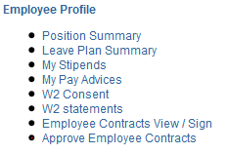

#### Action Required

Each instructor will receive an email notification from Human Resources when their contract is released for signature. Instructors are to provide e-signatures promptly once this email is received. If instructors do not virtually sign their contracts in a timely manner, reminder emails will be sent out by the Academic Administrator for e-Learning until the documents have been submitted to HR.



# Course Overload Authorization Form (For Instructors)

The form below is the official Course Overload Authorization form used at Ocean County College for faculty who wish to exceed the student-cap in an online course. Course overloads in Science courses are prohibited.

Online instructors, wishing to utilize this form, should complete the *Required Information* section at the bottom of this document and email it to the Academic Administrator of e-Learning, Britni Epstein, at [bepstein@ocean.edu](mailto:bepstein@ocean.edu) for authorization & processing.

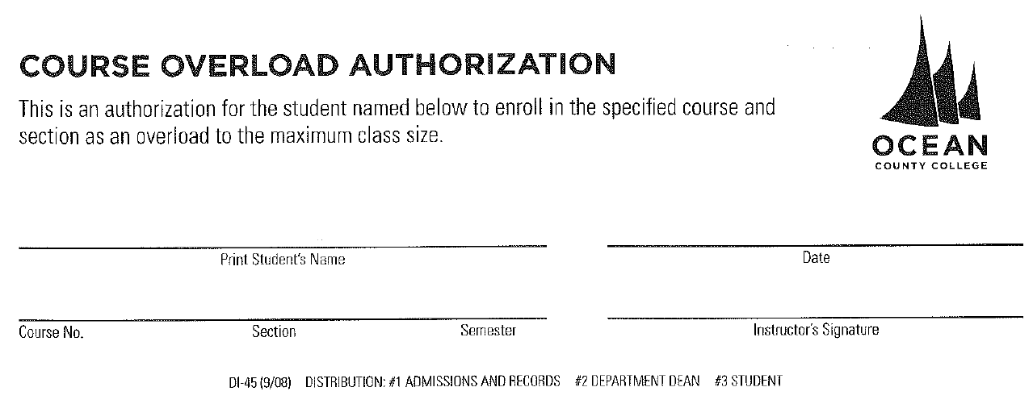

#### Required Information

Student Name \_ Course No. \_ Section \_ Semester \_

Date \_

Instructor’s Signature (Email Serves as Signature or if possible, sign & scan)



# Change of Grade Form

# (for Instructors)

The form below is the official Change of Grade form used at Ocean County College for faculty to change a submitted final grade for a student.

Online instructors, wishing to utilize this form, should complete the *Required Information* section at the bottom of this document and email it to the Academic Administrator of e-Learning, Britni Epstein, at [bepstein@ocean.edu](mailto:bepstein@ocean.edu) for authorization & processing.

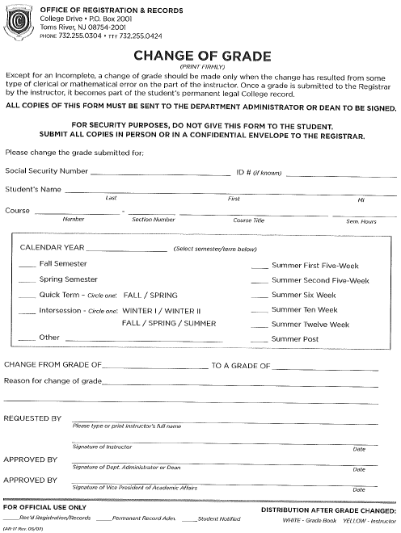

43

#### Required Information

Social Security Number

Student ID

Student’s Name Date Course Prefix/Number/Section Course Title Term

CHANGE FROM GRADE OF\_ TO A GRADE OF

Reason for change of grade

Requested by (print) Instructor’s Signature (Email Serves as Signature or if possible, sign & scan) Date /\_\_\_\_/ Approved by (Dept. Admin/Dean) Date /\_\_\_\_ / Approved by (VPAA) Date / /



# Policy 5180: Cheating and Plagiarism

1. Academic dishonesty includes, but is not limited to, plagiarism, cribbing, fabrication, misrepresentation, unauthorized collaboration, and/or cheating on any academic assignment submitted for a course as well as identity fraud in any face-to-face or distance learning course, exam, or academic exercise. Any student aiding another student in any form of academic dishonesty is considered equally guilty and subject to the same penalties.
2. Faculty shall inform their students about the importance of complete honesty in all academic work as it is understood within the academic discipline of the course. Departments may establish discipline specific-definitions of academic dishonesty to guide the Academic Affairs Committee on Integrity in the implementation of Procedure #5180.
3. For a reported and determined incident of academic dishonesty, the maximum academic penalty that a faculty member may assign is a course grade of "F" and, in the case of the final course grade of "F", the student shall be administratively withdrawn from the course. This report shall be in the student's disciplinary record.
4. The Vice President of Student Affairs may take further disciplinary action(s) against the student, with a maximum disciplinary penalty of expulsion from the College. This sanction shall be in the student's disciplinary record, according to Policy #5247, Conduct - Student Discipline.
5. Any student may appeal, in writing, the determination of academic dishonesty or the assigned academic penalty to the Vice President of Academic Affairs.
6. Students may refer to Procedure #5180 for appeal procedures.

ADOPTED: May 24, 1971 Revised: February 28, 2000

Revised: January 12, 1976 Revised: November 20, 2000

Revised: June 27, 1977 Revised: May 23, 2005

Revised: March 23, 1992 Revised: April 27, 2009

Revised: April 22, 1996 Revised: January 24, 2011



**Procedure 5180: Academic Dishonesty**

1. When a faculty member makes formal charges against a student involving academic dishonesty on any assignment, the faculty member shall report the charges to the department dean in writing.
2. Upon receipt of the written charges from the faculty member, the dean shall (1) consult with the faculty member, (2) send a copy of Procedure #5180, Academic Dishonesty to the student for the student's review, and (3) convene a meeting with the faculty member and the student to explain to the student the charges of academic dishonesty brought by the faculty member.

3. Until the faculty member and the dean resolve the matter, the student will not receive a grade on the assignment in question or if the incident occurs at the end of the semester, the faculty member will assign a course grade of “Incomplete.”

* 1. Upon determination by the faculty member and the dean that a student has engaged in an academically dishonest activity, and when the student declines to appeal this decision, the faculty member may assign the maximum academic penalty of a final course grade of “F” and, in the case of the final course grade of "F", the dean shall implement the administrative withdrawal of the student from the course. The dean shall notify the student, the faculty member, the Vice President of Academic Affairs, and the Vice President of Student Affairs in writing of the decision. The Vice President of Student Affairs may take further disciplinary action against the student in accordance with Policy #5247, Conduct - Student Discipline.

5. If the student chooses to appeal the decision or penalty of academic dishonesty made by the dean and faculty member, he/she must do so in writing to the Vice President of Academic Affairs.

1. Upon receipt of the student’s written appeal, the Vice President of Academic Affairs shall convene and chair the Academic Affairs Committee on Academic Integrity. This committee shall be appointed by the Vice President of Academic Affairs and shall consist of three faculty members, two from within the discipline and one faculty member from outside of the discipline or the department (excluding the faculty member involved in the case). The student making the appeal and the faculty member and dean who assigned the academic penalty may appear before the committee. The Academic Affairs Committee on Academic Integrity will make a decision on the student’s appeal.
2. The Vice President of Academic Affairs shall send copies of the final decision to the student making the appeal, the faculty committee members, the faculty member who assigned the academic penalty, the dean, and the Vice President of Student Affairs. The Vice President of Student Affairs may take further disciplinary action against the student in accordance with Policy #5247, Conduct - Student Discipline.

8. When it is determined that a student has not engaged in academic dishonesty, the student shall be allowed to continue the course without penalty.

9. All procedures within this document will be completed in a timely manner.

|  |  |  |  |
| --- | --- | --- | --- |
| ADOPTED: May 25, 1971 | | Revised: | November 20, 2000 |
| Revised: | February 25, 1974 | Revised: | May 24, 2005 |
| Revised: | January 12, 1976 |  |  |
| Revised: | February 26, 1996 |  |  |
| Revised: | April 30, 1996 |  |  |
| Revised: | April 25, 2000 |  |  |



**Evaluative Process for e-Learning Instructors**

In an effort to support our instructors and ensure a high-quality education for our students, the e-Learning Department conducts instructional observations. The e-Learning Department evaluates its online instructors every semester to ensure that they are complying with departmental expectations and evaluative criteria. Using OCC’s Record of Online Classroom Observation, form 3112.2DL (See Appendix B), the department provides feedback to adjunct and part-time instructors on an annual basis and for the first three terms of a new instructor’s employment. The same form is used for full-time faculty and college lecturers who teach in e-Learning as well.

**Evaluation Process:**

All faculty evaluators receive training prior to observing online instructors. This webinar consists of a PowerPoint presentation and live walk-through of the evaluation process. Evaluators are then provided with a Faculty Evaluator Checklist (See Appendix C) to guide the observation process. Instructors are provided with a copy of their evaluation, which they sign and return. The e-Learning Dean and Assistant Dean monitor all evaluations and follow-up with under-performing instructors to provide them with a remediation plan.

**Instructional Remediation Plan:**

When an instructional evaluation shows underperformance, or an instructor is otherwise not complying with e-Learning or OCC policies and expectations, we follow a corrective plan. We take corrective action in response to a number of problems, including but not limited to the following:

* Zero or minimal instructor involvement in discussion boards;
* Grade inflation (unwavering distribution of 100s with no justification);
* Zero or “stock” written grading feedback on assignments;
* Failure to address plagiarism;
* Failure to remind students of the attendance census date;
* Slow or absent responses to students’ emails;
* Unreasonably delayed grading;
* Infrequent course logins;
* Unprepared course (ex: no instructor contact information or assignment due-dates);
* Alteration of the course schedule to end the term a week or more early;
* Disrespectful or unprofessional communication;
* Failure to comply with OCC and e-Learning policies and procedures, including but not limited to:
  + Timely submission of final course grades;
  + Timely publication of course shell;
  + Timely submission of the final class roster/list;
  + Timely submission of final course grades.

When an instructor is under-performing, we immediately attempt to correct the situation. A combination of actions is used to remediate under-performing instructors and respond to instructional under-performance: reduction in teaching load, mentoring of the instructor, and a warning and re-evaluation. In serious cases of non-compliance, instructors are removed from their classes and replaced with another instructor, and any future teaching offers are rescinded.

**Professional Development:**

Each semester, the e-Learning Department hosts a kick-off meeting to welcome online instructors. During this meeting, the expectations for instructor performance are reinforced. In addition to these general meetings, which occur via WebEx, the department offers regular professional development webinars in subjects such as student retention, academic integrity, and best teaching practices. Instructors receive certificates for attending which can be used as a part of one’s application for promotion for adjunct instructors. See Adjunct contract for additional information regarding Adjunct Promotion Criteria.



**Process for Addressing Identified Deficiencies in**

**Online Instruction**

After a review of Drop-In assessments, policy-driven evaluations, and/or anecdotal information such as complaints from students, there will be an analysis of deficiencies in instructional performance as referenced in the aforementioned indicators. When these deficiencies are confirmed, the following process may be employed:

1. The assignment of a mentor to assist the instructor in achieving departmental standards for instruction;
2. The direction to participate in focused and directed professional development activities;
3. A reduction in the number of course sections taught in an upcoming term;
4. The removal from all future teaching assignments for a probationary period;
5. The removal from all future teaching assignments on a permanent basis.
6. The immediate removal from a current teaching assignment.

For the most part, the above actions will be progressive in nature depending upon the level of deficiency identified. The eLearning Department’s leadership reserves the right to bypass or amend the sequence of the above actions or combine them based on an analysis of the nature of the identified issues.

**Addendum**

| Vendor | Name | Title | Phone | email |
| --- | --- | --- | --- | --- |
| Barnes and Noble | Lisa Szymendera-Vota | OCC Bookstore Manager | Ext. 333 | SM8201@bncollege.com |
| Barnes and Noble | Trevor Kahl | IT Contact (Yuzu/Vitalsource/First Day) | 908-991-2467 | tkahl@bncollege.com |
| Canvas | Lauren Storer | Customer Success Manager (CSM) | 801-869-5085 | lstorer@instructure.com |
| Canvas | Cade Wilder | Customer Development Consultant | 801-822-4467 | cwilder@instructure.com |
| Canvas | Faculty Support | Canvas Faculty Support Hotline | 833-879-0864 |  |
| Canvas | Student Support | Canvas Student Support Hotline | 877-940-0472 |  |
| Cengage | Kristin Keesser | Key Account Manager | 917-399-4729 | kristin.keesser@cengage.com |
| Cengage | Andrea Iorio | Business Development Director | 847-682-9412 | andrea.iorio@cengage.com |
| Cengage | Peggy Shrader | Curriculum Solution Design | 847-702-6698 | peggy.shrader@cengage.com |
| Cengage | Larisa McGann | Customer Success Manager |  | larisa.mcgann@cengage.com |
| Cengage | Valerie Stone | District Manager |  | valerie.stone@cengage.com |
| Cengage | Larisa McGann | Field CSM |  | larisa.mcgann@cengage.com |
| Cengage | Jennifer Smith | Project Manager – Instructional Design & Delivery | 301-250-5877 | jennifer.smith@cengage.com |
| Cengage | Jennifer Reed | Instructional Designer | 501-773-3389 | jennifer.b.reed@cengage.com |
| Cengage | Rob Ellington | Educational Technologist | 513-892-9501 | rob.ellington@cengage.com |
| Examity | Jayme Silverman | Account Manager (Training/ Day-to-day operations) | 617-612-4136 | jsilverman@examity.com |
| Examity | Jessica Benjamin | Director – Business Development (Purchasing/Quotes) |  |  |
| Examity | Brian Bell | Account Manager (Training/ Day-to-day operations) | 1-857-226-8184 | bbell@examity.com |
| Hands-On Labs (HOL) | Naomi Buckta | VP Sales & Marketing | 303-803-3945 | naomi.buckta@emersivelearning.com |
| Hands-On Labs (HOL) | Andrew Fogoros | Account Executive | 720-485-6079 | andrew.fogoros@holscience.com |
| Hands-On Labs (HOL) | Joe Schubert | Account Manager | 720-485-6077 | Joe.Schubert@holscience.com |
| HonorLock | Nick Ferrari | Regional Sales Director | 518-209-9668 | nferrari@honorlock.com |
| LoudCloud | Brad Beatty | Director Business Development | 740-216-4234 (O) / 614-725-8997 (M) | brad.beatty@bnedloudcloud.com |
| MacMillan Learning | Noelle Gill | Publisher Rep |  | Noelle.gill@macmillan.com |
| McGraw-Hill | Megan Speranza | Enterprise Account Manager | 410-610-7644 | megan.speranza@mheducation.com |
| McGraw-Hill | Brady Robinson | Digital Learning Specialist | 484-752-2485 | brady.robinson@mheducation.com |
| McGraw-Hill | Technical Support |  | 800-331-5094 | njteam@mheducation.com |
| McGraw-Hill | Tiffany Berryman | Local Representative (STEM) |  | Tiffany.berryman@mheducation.com |
| McGraw-Hill | Russell Williams | Local Representative (BUSN, HUMN, SOC) | 267.746.1974 | Russell.williams@mheducation.com |
| McGraw-Hill | Sam Pilone | Local Representative (BUSN, HUMN, SOC) |  | Samantha.pilone@mheducation.com |
| McGraw-Hill | Kelly Mann | Math Implementation Consultant |  | kelly.mann@aleks.com |
| McGraw-Hill | Erin Farrey | General Implementation Consultant |  | erin.farrey@mheducation.com |
| McGraw- Hill | Erin Sanabria | Learning Specialist | 908-30-32972 | Erin.sanabria@mheducation.com |
| McGraw- Hill | Russell Williams | NJ Team Rep | 267-746-1974 | Russell.williams@mheducation.com |
| Pearson | Andrea Randazzo | Publisher’s Representative | 856-904-8765 | andrea.randazzo@pearson.com |
| Pearson | Allison Tierney | Digital Sales Specialist | 973-943-7090 | allison.tierney@pearson.com |
| Norton | Marley Lisker | Local representative | 212-354-5500 | mlisker@wwnorton.com |
| Norton | John Kelly | Media Specialist | 901-275-0627 | johnkelly@wwnorton.com |
| Rosetta Stone | Tracie Evans | Education Client Manager | 540-209-4368 (M) / 800-788-0822 ext. 5122 (O) | tevans@rosettastone.com |
| Rosetta Stone | Donald Quick | Higher Education Representative | 540-333-2797 (M) / 540-236-5026 (O) | donquick@rosettastone.com |
| Rosetta Stone | Support |  | 877-223-9848 | support@rosettastone.com |
| Sage College Publishing | Zachary Valladon | Inside Sales Representative I | 805-410-7733 | Zachary.Valladon@sagepub.com |
| Smarthinking | Lea Douglin | Sr. Account Implementation Manager | 202-487-6160 | lea.douglin@pearson.com |
| Turnitin | Adam Conner | Account Executive | 412-651-1010 | aconner@turnitin.com |
| Turnitin | Gabi Singh | Account Executive |  | gsingh@turnitin.com |
| Turnitin | Robert Trent | Solutions Consultant Lead -NOA | 607-592-6284 (M) / 510-764-7886 ext. 1094 (O) | rtrent@turnitin.com |
| Turnitin | Support (24/7) |  | 866-816-5046 ext. 241 | tiisupport@turnitin.com |
| Vital Source | VST First Day Team |  |  | VSTFirstDayTeam@ingramcontent.com |
| Wiley | Lisa Wilson | All disciplines besides the one below | 317-572-3527 | liswilson@wiley.com |
| Wiley | Blake Lisle | BUSN, Gen Studies, Architect, HUMN, International Affairs, Public Health, Science, Social Science, Tech Trade, and Tech Solutions | 678-399-2062 | blisle@wiley.com |
| Wiley | Allison Hammond | Hospitality, Language, Science, and Behavioral Science | 678-399-2063 | ahammond@wiley.com |
| WIRIS | Gaspar Perez | WIRIS Math Representative |  | gaspar@wiris.com |