# Incomplete Grades: How to Extend Due Dates in Canvas

Students who receive an “I” Incomplete Grade must be given extended access to all outstanding assignments in Canvas to complete their work. To give your student(s) access, you will need to extend the due dates in Canvas.

Please follow the steps below:

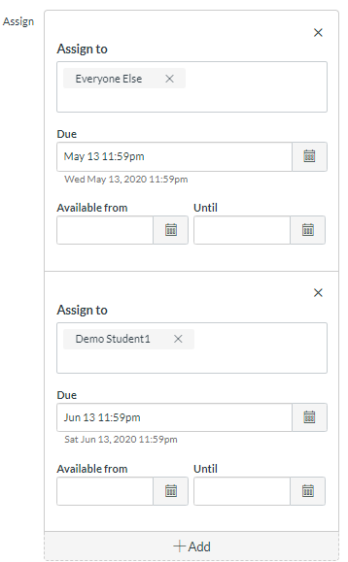

1. Access your existing course.
2. Select an Assignment/Quiz/Exam from the “Assignments” Page
3. Click “Edit” in the top right-hand corner of the Assignment
4. At the bottom of the Assignment page is the “Assign” box
5. Click the “Add” button at the bottom of the box
   1. In the new “Assign To” box, select the name of the individual student who needs extended dates.
6. Enter extended due dates
7. Click the blue “Save” button at the bottom.
8. The final product should look like the screenshot to the right with dates that may differ.

If you set “Availability Dates” on your assignments, you will need to extend these dates for the individual student as well.

More information about this process can be found in the Canvas Guide called [*“How do I assign an assignment to an individual student?”*](https://community.canvaslms.com/docs/DOC-9973-4152101242)

**Note: If you teach an integrated course with McGraw Hill, Pearson, Cengage, Hands-On Labs, or any other publishers, you will also need to extend the due dates on that platform as well. If you are unsure of how to do this, please contact [elearninghelp@ocean.edu](mailto:elearninghelp@ocean.edu) for details.