# Final Class Rosters

Final Class Rosters for your courses based on the official registration of each student through the end of the registration period will be available to you online through Ocean Connect > [Self Service](https://studentview-02.ocean.edu/Student/Student/Faculty). The census date can be found on the [Academic and Registration Calendar.](https://www.ocean.edu/programs-and-courses/calendar/)

Please certify your class rosters(s) and submit them through [Self Service](https://studentview-02.ocean.edu/Student/Student/Faculty) **no later**than the**3rd day after**the semester**census.**

**For e-Learning sections, any student who did not completed the Get Started: Orientation Quiz should be marked as “Never Attending.”**

# Step by Step Instructions

1. Log onto Ocean Connect. Click on “Self-Service for Faculty and Staff”. Select the Briefcase icon on the left navigation bar titled “Daily Work.” Click “Faculty” and then “Faculty Overview”

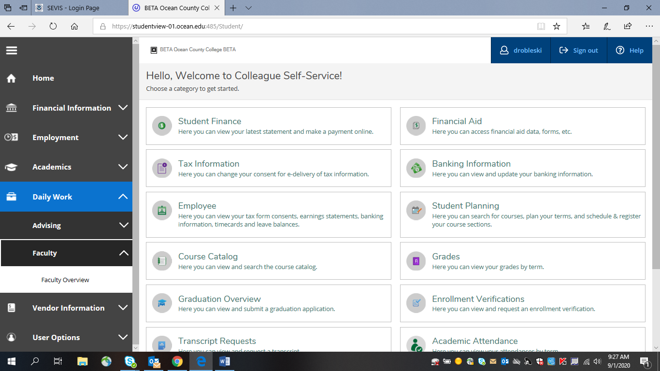

1. Select the course section from the list.

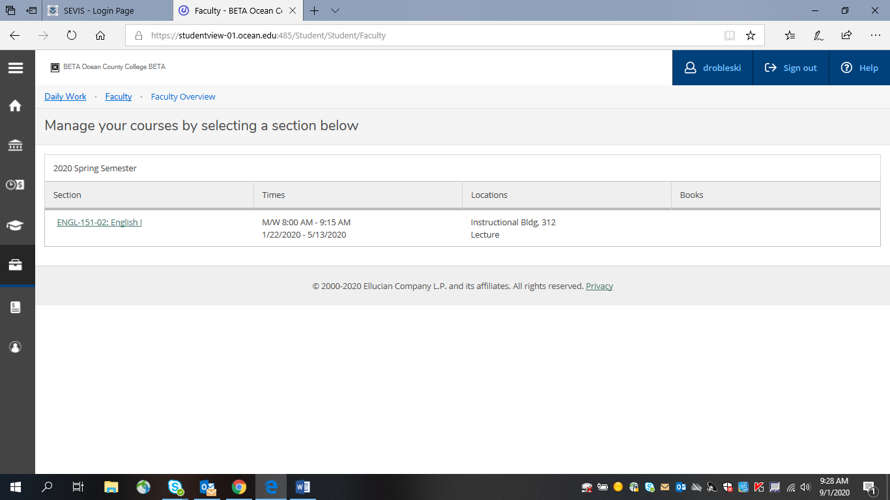

1. Select “FCL/GRADING” and then select “Final Class Roster”

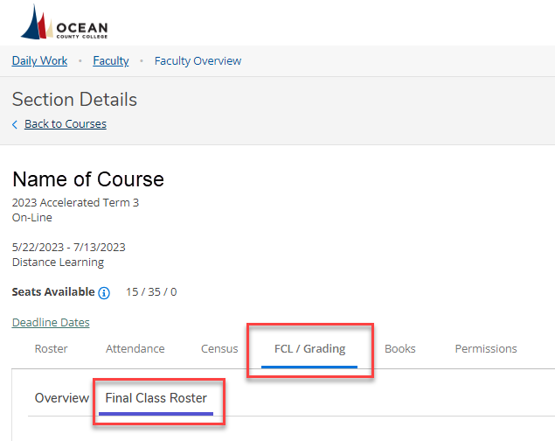

1. Select which students “NEVER ATTENDED” by checking the box under “Never Attended”

\**Note:* ***Do not*** *enter Last Date of Attendance or Midterm Grade\**

**Any student who did not complete the Orientation Quiz must be marked as “Never Attended.”**

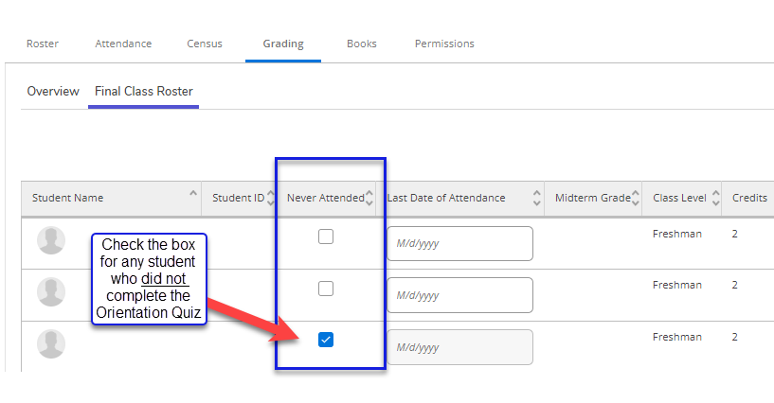

1. Once you have selected every student who Never Attended (any student who did not complete the Orientation Quiz), click “Final Class Roster Complete”

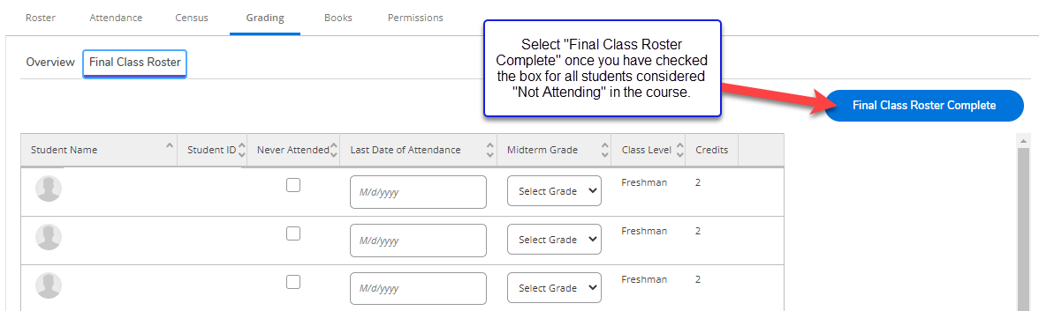

1. If you are ready to submit, select “Continue.” This will submit your final class roster. *Reminder, you will no longer receive an email confirmation.

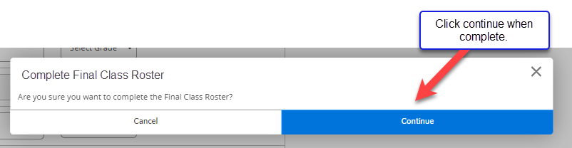

1. To verify that your roster was submitted, look for the “Final Class Roster Complete” button and notice that the button will turn gray and show the date and time of completion.

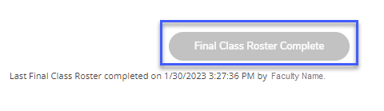

If you have questions regarding this process, please email [registrar@ocean.edu](mailto:registrar@ocean.edu).

# e-Learning Tips

**\*Remember, a student is only considered to have participated in Census by completing the Get Started Module: Orientation Quiz.**

Posting a discussion, submitting an assignment or assessment will not count as “attending” if the Orientation Quiz is not complete. Emailing, communicating via Canvas Inbox, or simply logging in do not count as census participation.

# Additional Information

If a student has not attended, they will not be withdrawn for having “never attended.”

You will however, acknowledge their “never attended,” through [Self Service](https://studentview-02.ocean.edu/Student/Student/Faculty).

Remember, this does not withdraw a student. Do not enter a “W” as a grade. They are still registered for your course and should be given a final grade, according to your syllabus. Students who wish to withdraw themselves will need to follow the procedure found on the [Course Withdrawals](https://www.ocean.edu/student-services/course-withdrawals/) webpage.

Any student not on the class roster at this point has neither registered nor paid for the class.  
***It is too late to add new students to courses.***

You may only submit this roster once. Once it is submitted, you cannot make any adjustments. If you realize that you made an error, (such as marking a student as never attended) you need to contact the Registration & Records office to make any corrections ([registrar@ocean.edu](mailto:registrar@ocean.edu)). Students who choose to withdraw after this point must withdraw online via Ocean Connect.

You will no longer receive a confirmation email when your roster has been submitted.

Submission of final class list rosters is required by the college’s auditors in order to verify attendance and payment from the State of New Jersey based on enrollment.

Disregard of this deadline could cause a student’s financial aid to be withheld because attendance is not verified. In addition, insurance companies and the IRS conduct spot checks to certify student attendance when parents claim them as dependents.

**If you have any questions/concerns regarding your class rosters, please feel free to contact the Office of Registration & Records at**[**registrar@ocean.edu**](mailto:registrar@ocean.edu)