# Sample Format Essay

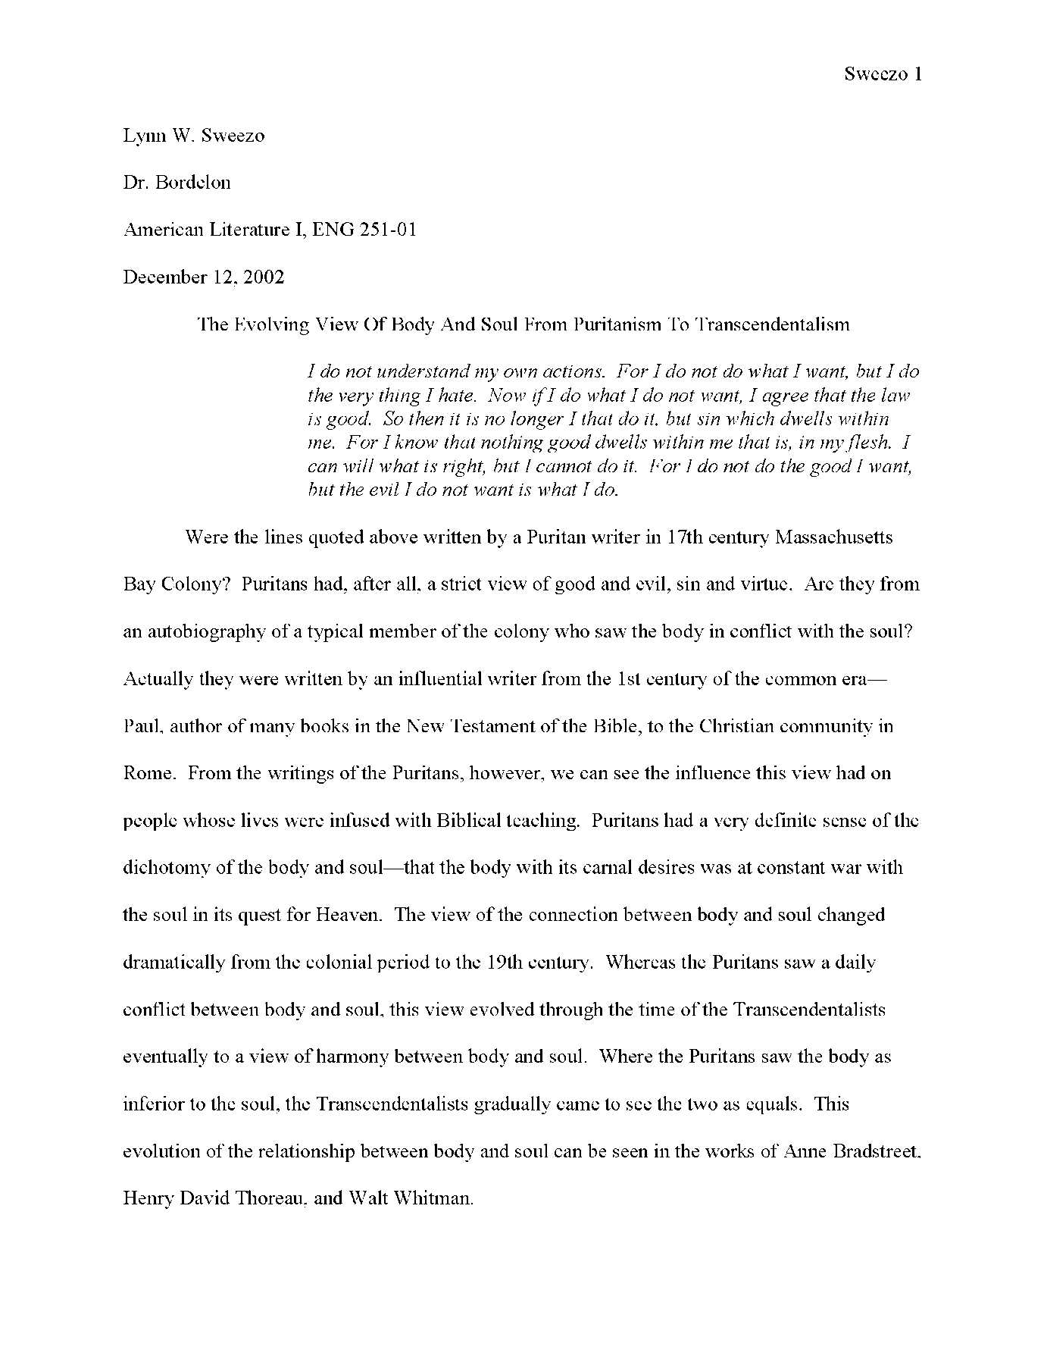11 or 12 point Roman or Times font. Double spaced and 1 inch margin. Last name and page number in header. See course site for instructions on adding header and setting up a works cited page.

