Pictures for American Lit Web Site

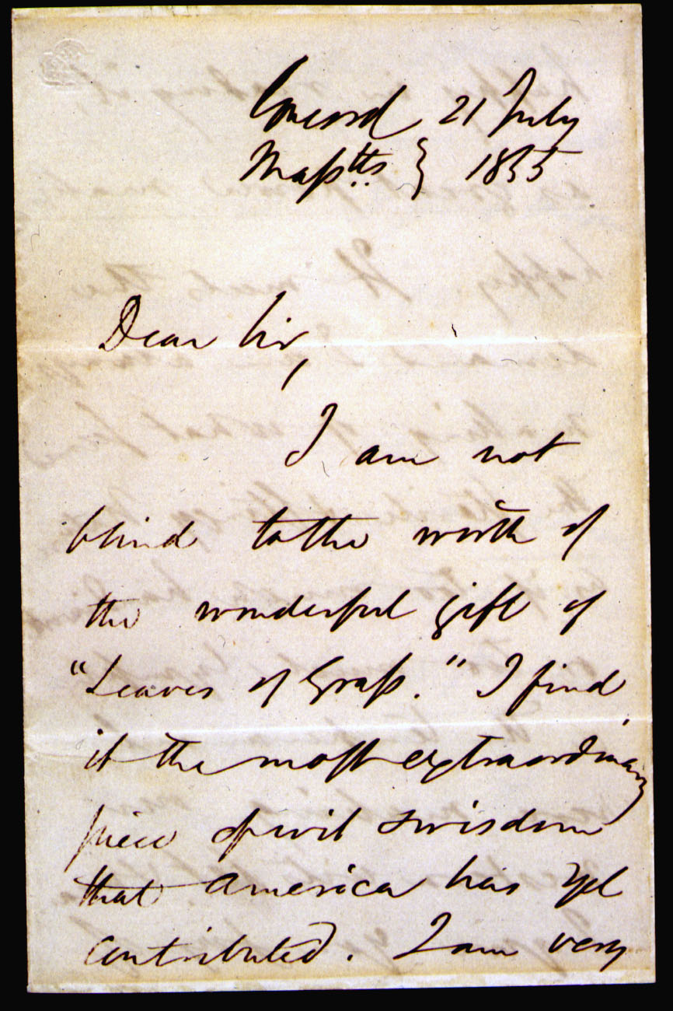 | 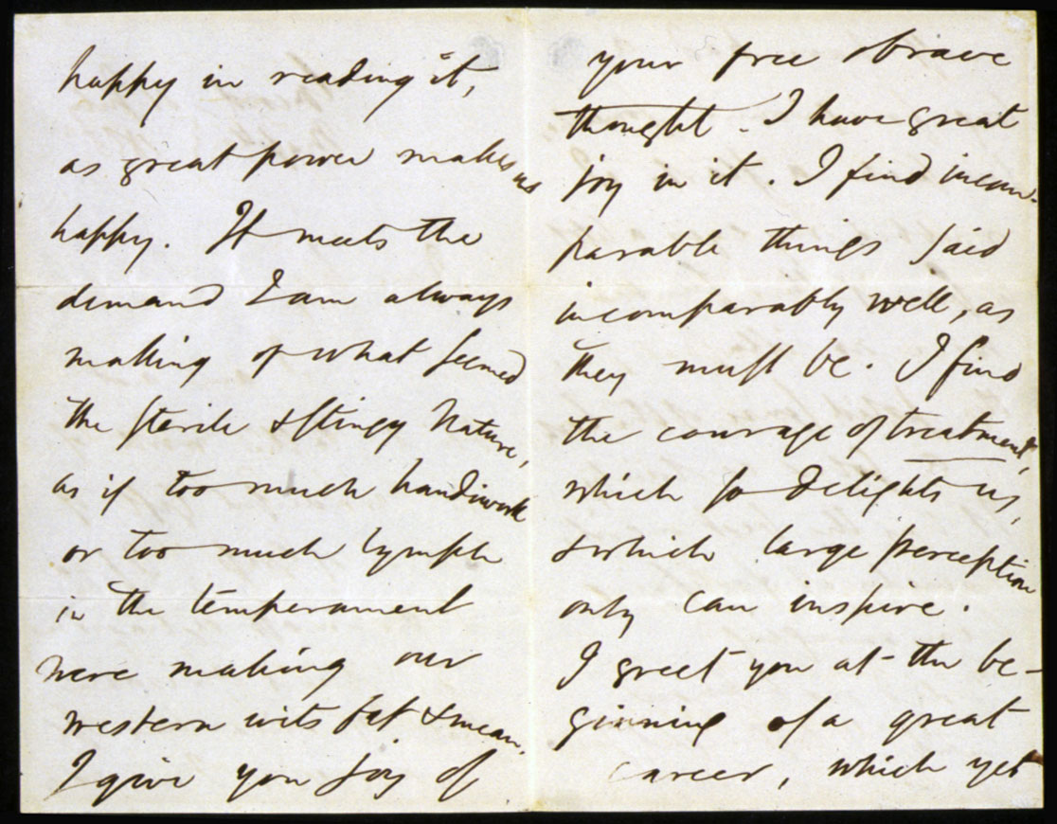 | 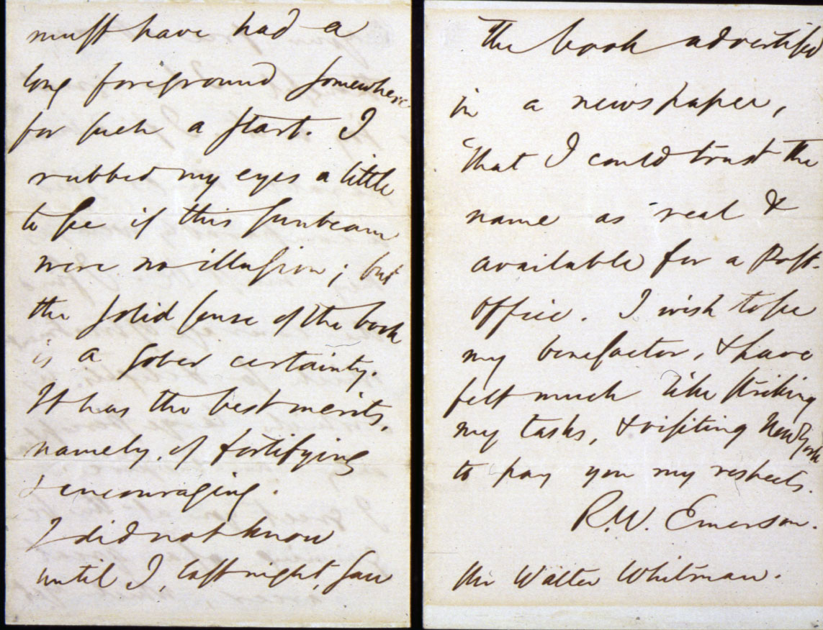
Letter from Emerson to Walt Whitman

Manuscripts from Dover book

Draft of Walden
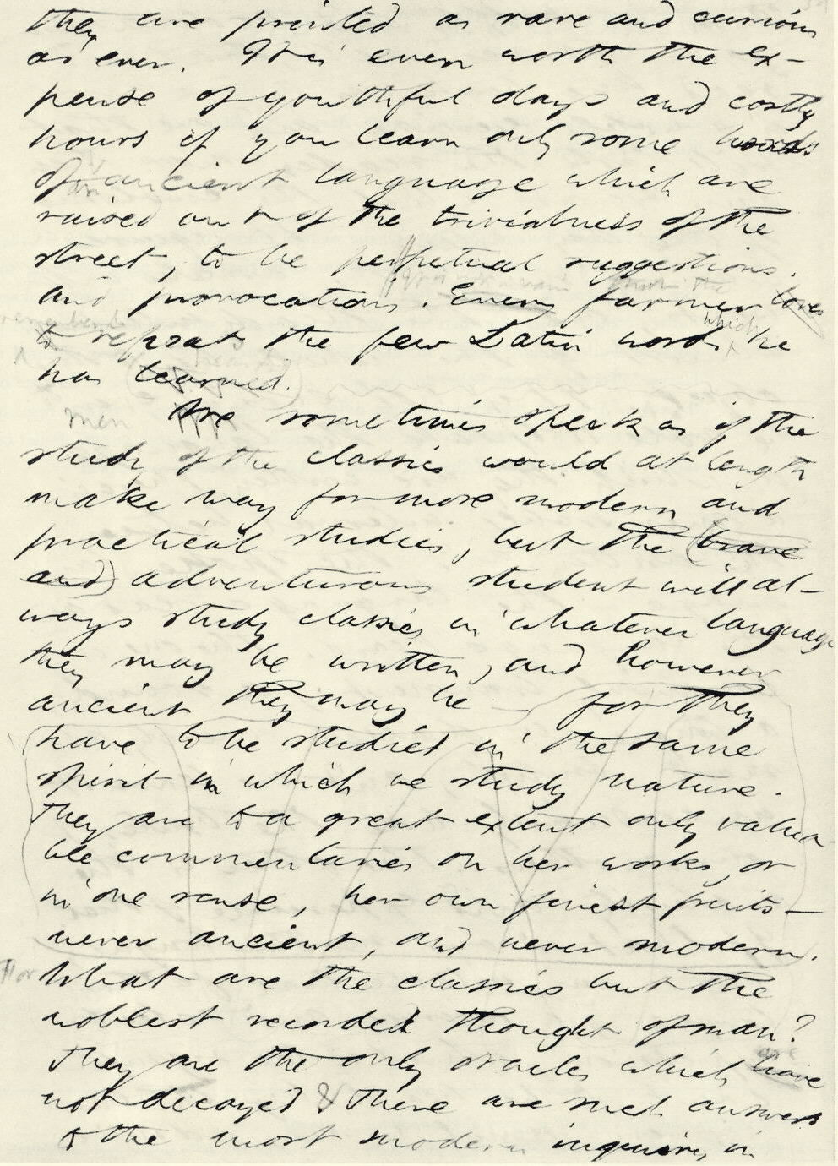

http://www.library.upenn.edu/special/gallery/kislak/colonial/rowlandson2.html
pictures of first edition of text

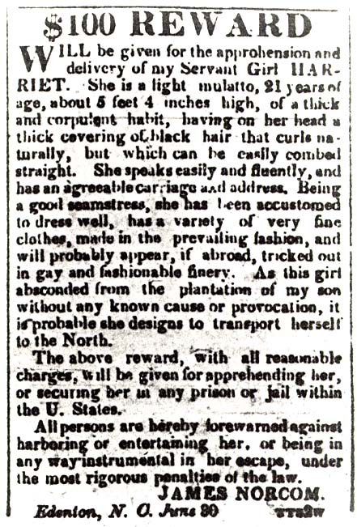
Image Credit: Copy from the American Beacon, July 4th 1835, Courtesy of the North Carolina Division of Archives and History

A page from a New England Primer printed in Boston by Ira Webster in 1844. While this is from a much later period, similar primers were used by the Puritans from the late 1700s.
(images from http://www.iupui.edu/~engwft/slide16l.gif and http://www.iupui.edu/~engwft/slide17l.gif )

