# Organizing Your Information to Draft Essay

Consider these choices

Reasons and Evidence Sheet | Copying and Pasting Thesis for Organizing | Formal Outline

## Reasons and Evidence sheet

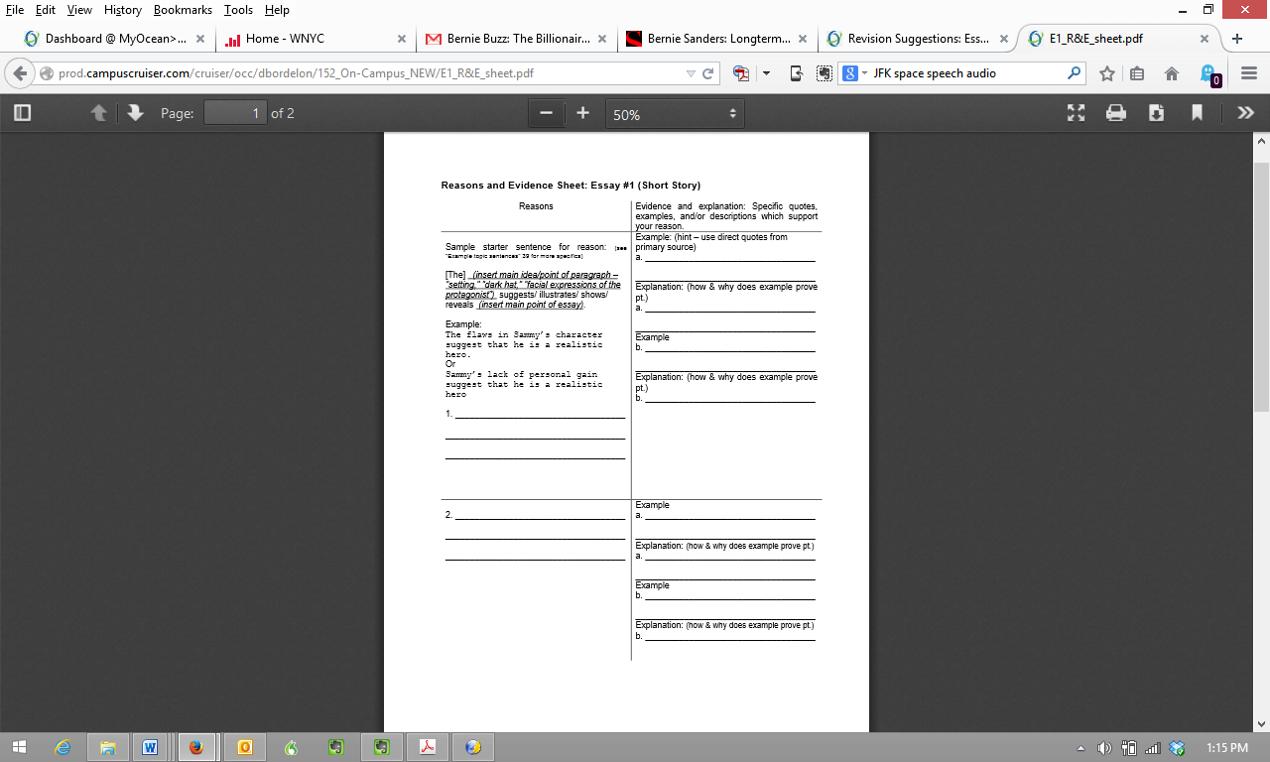

PDF <http://prod.campuscruiser.com/cruiser/occ/dbordelon/152_On-Campus_NEW/E1_R&E_sheet.pdf\>

Computer file: <http://prod.campuscruiser.com/cruiser/occ/dbordelon/152_On-Campus_NEW/E1_R&E_sheet.rtf>



## Copying and Pasting Thesis: Making Quick Topic Sentences

Gimpel is no fool because unlike the rest of the town he is compassionate, tactful, and a genuine person

Gimpel is no fool because he is compassionate.

DEFIINITION OF COMPASSIONATE

QUOTES THAT SHOW GIMPEL IS COMPASSIONATE

EXPLANATIONS OF QUOTES

Gimpel is no fool because he is tactful

DEFIINITION OF TACTFUL

QUOTES THAT SHOW GIMPEL IS TACTFUL

EXPLANATIONS OF QUOTES

Gimpel is no fool because he is genuine person

DEFINITION OF GENUINE

QUOTES THAT SHOW GIMPEL IS GENUINE

EXPLANATIONS OF QUOTES



## Formal Outlining

1. Introduction
   1. Grab reader with first sentence
   2. Mention author’s name and story
   3. Define any terms
   4. Thesis and division
2. Topic sentence division 1
   1. Definition of any terms/ideas to frame paragraph
   2. Set up of quote
   3. Quote
   4. Explanation of how quote proves point of paragraph
   5. Repeat
   6. Sentence to wrap up
3. Topic sentence division 2/second paragraph on division 1 (note that suggestion here is that you can develop a division over two paragraphs)

Continue this format