**The Body of the Essay**

**BUILD YOUR BODY** - Take the points from you brainstorming list and your evidence that you found in the form of quotes and follow the pattern below.

When writing a college research essay, think of the essay’s body like a **hamburger.**

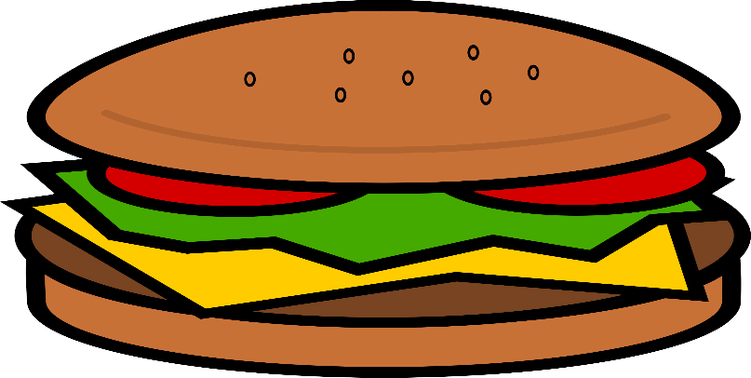

**Building the Body of your Research Essay**

If you think of the body of your essay like a hamburger, then creating your essay should be easy. Follow this pattern for help.

**BUN** – In both cases the bun –the beginning of your paragraph and the end of your paragraph should be your OWN words.

* Make you’re 1 major point you want to discuss in the paragraph by writing it in your own words.

**EX.** The man in Jack London’s “To Build a Fire” makes many mistakes that cause his own death. His first mistake is that he doesn’t listen to the old timer who warned him not to travel alone.

**MEAT, CHEESE & CONDIMENTS** – think of these middle pieces as the quotes and proof you will use to support your points. Thus, these should be direct quotes or block quotes. These usually come from both the primary text and secondary sources –outside sources written by others who have analyzed the text.

**EX.** Jack London writes, “He remembered the advice of the old-timer on Sulphur Creek, and smiled. The old-timer had been very serious in laying down the law that no man must travel alone in the Klondike after fifty below” (London 7).

**BUN** – Finally, return to your own words. EXPLAIN how the quote/evidence supports your point.

EX. Clearly, London’s quote shows that the man was inexperienced and did not listen to the old-timer. He thought he could travel alone and ignore the advice of the old man; however, he was wrong.



**NOTE:** Before you end your paragraph with your bun, be sure to put it on a plate—use transition.