

**Ocean County College**

**School of Arts and Humanities**

**School of Arts and Humanities Handbook**



Academic Year 2017/2018

**FACULTY AND STAFF DIRECTORY**

Heidi Sheridan , Dean Debra Pfaff, Academic Administrator

732-255-0400 Ext. 2190 255-0400 Ext. 2286

[hsheridan@ocean.edu](mailto:hsheridan@ocean.edu) [dpfaff@ocean.edu](mailto:dpfaff@ocean.edu)

Karin Smith, Administrative Assistant Maria Galindo, Administrative Asst.

732-255-0400 Ext. 2097 732-255-0400 Ext. 2193

[ksmith@ocean.edu](mailto:ksmith@ocean.edu) [mgalindo@ocean.edu](mailto:mgalindo@ocean.edu)

Direct lines into The School of Language and the Arts

English 732-255-0376

Humanities 732-255-0338

**IMPORTANT PHONE NUMBERS**

**Weekend and Evening Services** (after 4:00pm)

Ray Dondero

Bartlett Building, Room 212 **Russell Writing Center**

732-255-0400 Ext. 2449 732-255-0400, Ext. 2083

**Russell Fax Number Grunin Fax Number**

732-864-3862 732-864-3866

**Russell Computer Laboratory Human Resources**

732-255-0400 Ext. 2986 732-255-0400 Ext. 2093

**Information Technology Help Desk Security**

732-255-0400 Ext. 2144 732-255-0400 Ext. 2170

**Southern Education Center**

Katie Grofik, Administrator,

Off Campus Locations

[kgrofik@ocean.edu](mailto:kgrofik@ocean.edu)

732-255-0400, 2278

Dear Faculty Member:

Welcome to a new semester in the School of Arts and Humanities at Ocean County College. This brief handbook was designed to assist you with becoming familiar with departmental routines, and being comfortable and knowledgeable about your position.

**TABLE OF CONTENTS:**

**Section I: Teaching Tools:**

1. Syllabus
2. Textbooks
3. Supplies
4. Ocean Connect/Accessing Class Lists/Certifying Class List
5. Entering Final Grades
6. Course Withdrawals/Absence Warning Notification/Notice of Unsatisfactory Progress
7. Civility Statement
8. Key Semester Dates
9. Plagiarism & Academic Dishonesty
10. *Ocean Connect & Canvas*
11. *Online Gradeboo*k
12. Copy Services

**Section II: Policies & Procedures:**

1. Student Evaluations
2. Honors by Contract
3. WAC – Writing Across the Curriculum Guidelines/WAC Fax Cover Sheet
4. Assessment
5. Proctoring Exams
6. Absent Reporting Form
7. Applying for Promotions

**Section III: Campus Extras & Help:**

1. Library/Information Literacy Orientations
2. Russell Computer Lab
3. Writing Center
4. Document Camera/Laptops
5. Adjunct Faculty Mailboxes and Office Space
6. Off-Campus Teaching Assignments
7. College Facilities
8. Counselling/C.A.R.E.
9. Map of Campus

**SECTION I: TEACHING TOOLS:**

1. **Syllabus:**  **What belongs on my syllabi:** The following categories must be included on all syllabi: Professor’s name, course title and number of the course, college catalog description, email where you can be reached, course learning outcomes/objectives, general educational goals, grading scale, attendance policy, course outline for the semester, and a plagiarism statement. **T*he learning outcomes/objectives and general educational goals should be taken from the* Official Course Description and copied/pasted exactly as they are written**. Official course descriptions can be accessed from **Ocean Connect>Clubs and Offices>Governance Committees>Academic Documents>Curriculum Documents>Official Course Descriptions**

**Submit your syllabi for approval:** Once your syllabi are completed, send them to [***SYLSLA@ocean.edu***](mailto:SYLSLA@ocean.edu)***.***Syllabi **must** be submitted for approval before they are copied and distributed to your class. Syllabi should be sent/approved at least two weeks before classes start. You will be informed of this date via an email reminder.

1. **Textbooks:** Textbooks for classes are selected by the Dean and the textbook committee, and are available for students to purchase in the College Bookstore. Use of these texts assigned to each course is **required;** no substitutions may be made without prior approval from the interim Dean, Heidi Sheridan at 732-255-0400, 2190, or via e-mail at [hsheridan@ocean.edu](mailto:hsheridan@ocean.edu). Faculty may add exercises or outside readings that are copied; however, readings should be short. Ex. One or two poems may be copied or a short essay or grammar exercise; however, faculty may not add a play, novel or longer reading without approval. Copies of textbooks can be obtained from Karin Smith for English or Maria Galindo for Humanities courses. Please contact them at [ksmith@ocean.edu](mailto:ksmith@ocean.edu) or [mgalindo@ocean.edu](mailto:mgalindo@ocean.edu) to arrange a time to pick up your texts.
2. **Supplies:** If you are teaching in the Russell building, you can find supplies, such as chalk, a gradebook, pens, pencils, paper clips, etc. in the storage room next to the mailboxes outside Karin Smith’s office—Room 217. If you are teaching a course in another building, please see Maria Galindo in Grunin Center, Room 102 for the same supplies. Faculty can help themselves and do not have to ask for these supplies. However, if you take the last of an item, please email Karin or Maria, so more that supplies can be ordered. There are three loaner laptops, and two document cameras that can be signed out through Maria or Karin.
3. **OCEAN CONNECT/Accessing Class Lists/Certifying Class Lists:** Know that anything you need to gain access to or submit will be done through **Ocean Connect**. (All information such as locating a class list, withdrawing a student from your course, submitting a final class list, submitting grades, etc. will be done in Ocean Connect, and you will use the **WebAdvisor for Faculty** button to locate this material).

**Ocean Connect’s main screen will look like this:**

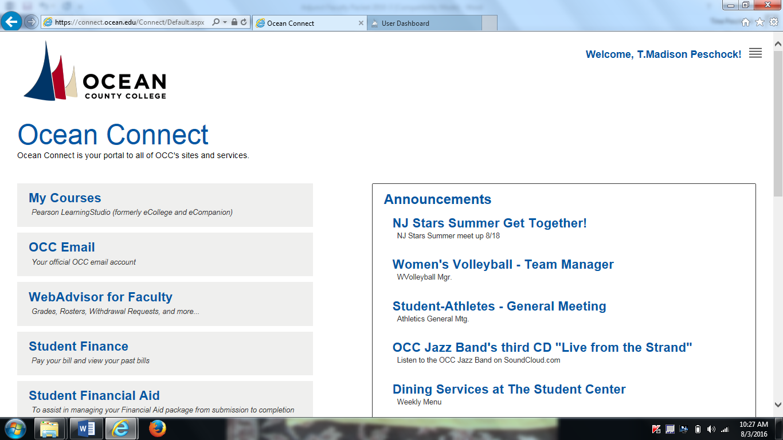

**Class Lists:** Initial class lists are available online, using *Ocean Connect.* It is important to check your **online roster frequently during the first 10 days of the term**, as students often add and drop sections daily, or are dropped for non- payment. It is absolutely essential that **each** student in attendance be registered in your particular section on or before the attendance census date for each term. To access your course list, go to Ocean Connect and follow the steps:

* Click on **WebAdvisor for Faculty.** (when open, it will look like the screen below:

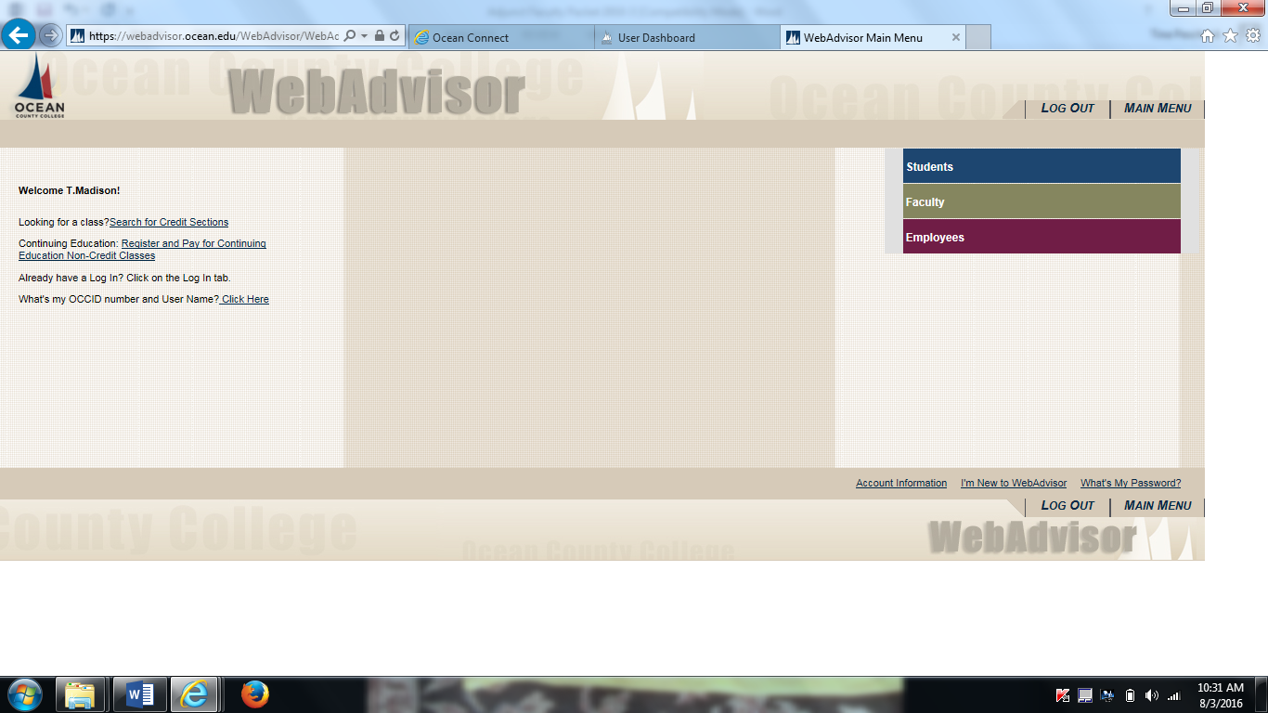

* Once in WebAdvisor, click on **Faculty,** you will be taken to a new screen with different categories. Under **Faculty Information,** click on **Class Roster**.
* Then, click on the **name of the course** for the list you want to access. Ex. ENG 152-02. Your class roster will be displayed. Print this out for each class meeting, and be sure to use it to take attendance. You should check this for each class meeting until the drop/add period ends. Add/drop period date changes every semester. Once the add/drop period is over, you will need to certify your final class roster.

**Certifying your final class roster:** To certify your final class roster, you need to access Web Advisor:

Under **Faculty Information** click on Final Class Roster.

* **Click on the specific section** you are going to certify as a complete & final roster. (You will need to repeat this step multiple times for each roster).
* At this time you are able to withdraw students for non-attendance. If you have a student on your roster who has not attended class in the drop down menu next to their name click on never attended.
* In addition, if a student has only attended the first class you may also withdraw this student due to attendance. To do so in the drop down menu next to the students name click **stopped attending on,** and in the text box include date.
* Click **submit** to finalize the course roster. (You will need to repeat this step

for each roster).

1. **Entering Final Grades:** Throughout the semester you are required to keep organized records of grades for each student. You should keep both a paper gradebook and insert grades online. To submit final grades, please be sure you are ready to provide final grades to an entire class. Partial grading of a class is not accepted. Once grades are entered, they are official and will be available to the students.To submit final grades in WebAdvisor.

* Under **Faculty Information** click on **Grading**. You will be taken to a new screen.
* Select the **semester/term** for which you want to submit grades.
* Click on **section & class** for which you want to enter grades. Enter your grades. (Be sure to hit **SUBMIT** so that your grades are submitted. Once your grades are submitted, you will receive an e-mail confirmation.

AttendanceIt is extremely important that you take attendance **daily** and keep records of each student’s attendance in your course. Instructors must add the specifics of their attendance policy to their syllabus. How you do this is up to you as an Instructor; however, you should also take attendance in ***Ocean Connect*** every day. To take attendance please go to the Faculty page in WebAdvisor and follow the steps below:

* Click on **Take Attendance**. Once you do this, you will be taken to a new screen.
* The new screen will have all of your classes listed for the semester. Click on the **specific class** for which you want to take attendance.
* Click on the **specific date** for which you want to take attendance. Once you click on the date, you will be taken to a new screen with your students’ names.
* Finally, click on each **student’s name** and click the **appropriate daily attendance.**

*Please be advise attendance can also be accessed through your Canvas courses. Clicking on the attendance link in your Canvas courses will take you to the attendance tool in WebAdvisor.

1. **Course Withdrawals:** Instructors should remind students to withdraw from the class by the withdraw date if they are failing the course. This will help students avoid earning a failing grade. Once a student initiates a course withdrawal, instructors will receive an email alert. Instructors are required to process student withdrawal requests in a timely manner. Once on the faculty page in WebAdvisor follow the steps below.

* Click on **Withdraw Requests**.
* Click on course section. Here you will see the name of the student who has asked to be withdrawn from your course.
* Next, **click on the name of the student**(s) and hit **submit**.

1. **Civility Statement**: Ocean County College defines civility primarily as the demonstration of respect for others, basic courtesy, reciprocity (treating others as we wish to be treated), and behaviors that create a positive environment in which to learn and to work.

The Trustees of the College and the College Administration set the tone for civil behavior through their professional conduct and through their leadership of the institution. All members of the college community create a positive environment characterized by considerate and principled conduct.

While no civility statement can guarantee considerate and principled conduct, the values set forth herewith represent institutional ideals and should serve as guide posts:

1. Respect for the work of all persons
2. Courteous discourse (oral, verbal, non-verbal and electronic)
3. Honest interactions and utterances
4. Fair and just treatment
5. Integrity and keeping promises
6. Commitment to the community college philosophy; Access, transfer, career preparation, workforce development, partnering, and community outreach.

<http://www.ocean.edu/welcome/mission_vision.htm>

1. Open professional communications
2. Diversity, professional communications
3. Free expression of views without meanness or a desire to do harm.
4. Tolerance of differing points of view
5. Zero tolerance for any forms of cyber stalking, cyber bullying, or cyber sexual harassment (see the Attorney General’s letter)
6. A culture of honor that enhances our student ethical and moral development and clearly communicates and consistently adheres to the definitions of and sanctions for academic dishonesty.
7. **KEY SEMESTER DATES:**

**Fall 2017**

* Classes begin: 9/6/17
* Final class list e-mail to faculty: 9/19/17
* Attendance census (10th day): 9/19/2017
* Final class lists available: 9/20/2017
* Final class lists due back: 9/26/17
* Deadline to withdraw: 11/10/17
* Grade access to faculty: 12/8/17
* Classes end: 12/22/17

1. **Plagiarism & Academic Dishonesty:** Instructors MUST have a plagiarism policy and an academic dishonesty policy in their syllabi. The specifics of the policy must be spelled out clearly. Know that OCC takes academic dishonesty and plagiarism very seriously. However, it is ultimately up to the Instructor to take action against the student by meeting with the student and the Dean if action needs to be taken. Also, Instructors should take a multi-pronged approach to avoiding plagiarism: (1) teach students what plagiarism is; (2) enforce the OCC plagiarism policy; (3) control the sources students are permitted to use for assignments; (4) use [www.turnitin.com](http://www.turnitin.com) or [www.google.com](http://www.google.com) to detect plagiarized work; and (5) distinguish between unintended errors in documentation and calculated dishonesty.
2. **Ocean Connect & Canvas:** Ocean Connect is the main platform used by Ocean County College, linking to Canvas, OCC e-mail, the Hub, Library, One Drive and WebAdvisor. **Canvas** is new to OCC for Fall 2016, and it is the learning management system used to stay in contact with students, keep an online gradebook, share documents, assignments, and syllabi with students, and manage course online. Canvas is accessed through Ocean Connect by clicking on **MY COURSES**. It is important that you understand how to use both platforms.
3. **Online Gradebook:** You should keep both a hand-written gradebook and an online gradebook. Students should be aware of their grades at all times. By doing so, you, as an Instructor, can avoid issues if a grade appeal should arise. To set up your online gradebook and access your courses in *Ocean Connect*

* Click **ALL COURSES**, which will be underneath your name. You will be taken to a new screen that lists all of your courses.
* Click on the specific class you want to add grades for

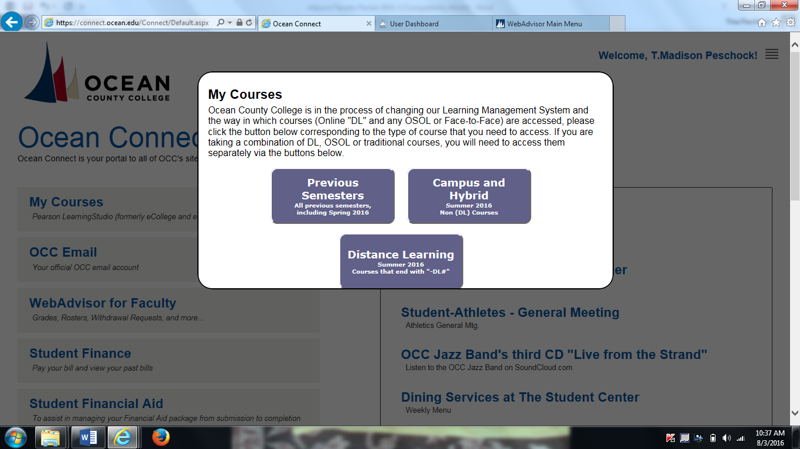

* You will now be taken to a new screen. Be sure to click on **COURSES** on the left side of the screen. (See Screen shot below).

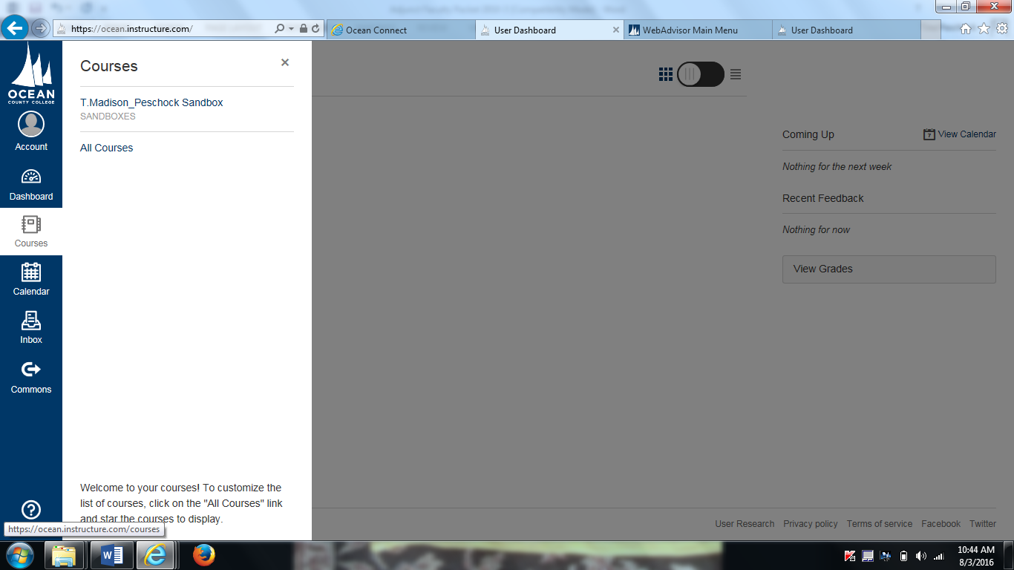

**Online gradebook:** To set up your online gradebook, hit **Assignments**. Add **ALL** of your assignments and their point values immediately at the beginning of the semester. (Look at screen shot below).

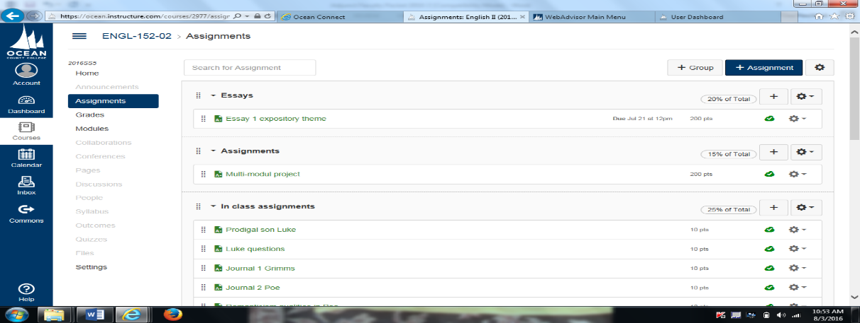

* To add an assignment to your gradebook, click on the **PLUS SIGN** that DOES NOT SAY ASSIGNMENT. Once you do this a new screen will be generated that look like the one below:

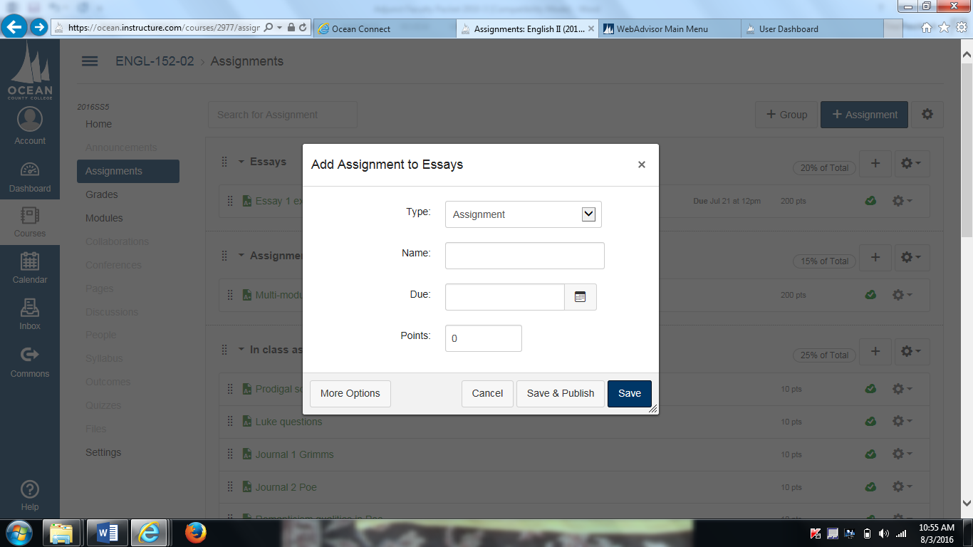

* Next, under **TYPE**, select the type of assignment. Name the assignment. If you WANT to, set a due date by clicking on the miniature calendar, and add the point value for the assignment. Finally, save what you have entered. (This information will now be populated in your gradebook.
* Before you leave the Assignment page, be sure to **click on the miniature grey cloud**. It will turn green. This will allow you to publish this information. Once it is published, it will appear in your gradebook and be accessible to students.
* Next click on the **Grades Tab**, which is located on the left hand side under Assignments. You will be taken to a new screen that lists your students’ names and all of the assignments you have entered. Once you are ready to enter in scores for specific assignments, simply click on the box underneath the specific assignment for each student. Enter the score, and you are done.
* EXTRA HELP: For other specifics regarding Canvas, such as how to upload a course syllabus, or to learn the ins and outs of Canvas, contact Janine Dillard at: [jdillard@ocean.edu](mailto:jdillard@ocean.edu).

1. **Copy Service Form:** Please limit copying to **ten** on copiers located in any

academic office. Print jobs should either be e-mailed to [occtransfer@gangigraphics.com](mailto:occtransfer@gangigraphics.com) or interoffice mailed to Gangi Graphics, 732-840-8680.

**SECTION II: POLICIES & PROCEDURES:**

1. **Student Evaluations:** Directions to access the student evaluations at the end of the semester will be announced during the semester.
2. **Honors by Contract :** A reminder that **Honors by Contract** paperwork is due by the census date.  The most up to date list of courses will be circulated at the beginning of semester.
3. **Assessment** - Ocean County College conducts course-level assessment in the high-enrollment courses noted in the chart below. During the fall semester, faculty members prepare for the upcoming spring assessment by reviewing the course objectives, assessment instruments, and previously collected assessment data and findings. During the spring semester, all full-time faculty and adjuncts teaching the designated courses must administer the assessment in at least one course section unless the dean has determined that the instrument is a departmental exam or project that is to be used in all sections.

|  |  |  |  |
| --- | --- | --- | --- |
| **Arts and Humanities** | **2017SP** | **2018SP** | **2019** |
|  | ARTS 181 | HIST 171 | ENGL 091 |
|  | ARTS 182 | HIST 172 | ENGL 095 |
|  | COMM 154 | HIST 173 | ENGL 151 |
|  | PHIL 191 | HIST 174 | ENGL 152 |
|  | SPAN 152 |  |  |

1. **roctoring Exams**: Exams may only be administered during regularly scheduled time blocks. If the testing center blocks do not meet the student’s needs, alternate arrangements will have to be made between the professor and student. Instruction sheet and forms are available through the faculty and staff portal under forms and then Testing Center
2. **Absence Form** – When you are unable to meet the class for any reason, please e-mail Heidi Sheridan, Debbie Pfaff, Karin Smith(English), or Maria Galindo (Humanities), respectively depending on your discipline. As a follow up to your absence, please fill out an absence reporting form. This form is available in the academic office.
3. **Applying for Promotion**: Please see adjunct faculty contract by following these steps:

1. Click on Ocean Connect from the ocean.edu web site.

2. Click on Faculty and Staff Portal.

3. Click on References and Benefits.

4. Click Benefits and Contracts.

5. Click on Adjunct Faculty Contract.

**SECTION III: CAMPUS EXTRAS & HELP:**

1. **Library/Information Literacy Orientations:** Instructors may make arrangements for library and information literacy orientations for reading, composition, or literature classes by contacting Library Reference Services or by filling out and submitting a library orientation request form (available in the office). Instructors are expected to remain with their classes during library orientations.
2. **Russell Computer Laboratory:** The Computer Lab, located in Room 238 in the Russell Building, is available for use by day and evening students, on a seat-available basis. Each semester, the Lab Technician will post the current Lab schedule, or you may phone the Lab at Ext. 2986.
3. **Writing Center:** Free tutoring is available in The Writing Center, Russell Building (#7) Room 124 for all students.

**Fall semester hours**

Monday/Thursday-9:00-4:00 p.m.

Wednesday/Friday-9:00-2:00 p.m.

Tuesday-9:00-7:00 p.m.

For more specific information, contact the center at extension 2083. The Writing Center also offers help at the SEC campus, and virtual tutoring. Consult The Writing Center webpage at *Ocean.edu* for hours and writing help.

1. **Departmental Laptops/Document Camera:** There are three laptops stored in the academic offices and two document cameras which can be signed out during the semester. Instructions for document camera use are available in the office and through I.T.
2. **Adjunct Faculty Mailboxes and Office Space:**

* Bartlett-room #210/phone no. Ext.2934/computers
* Grunin-room #113/phone no. Ext.2107/computers
* Gateway-room #204/computers
* Russell-room #245/phone no. Ext. 2409/computers
* Technology-room #223/phone no. Ext.2311 /computers

1. **Off-Campus Teaching assignments:** Adjunct faculty who teach at off-campus sites

should direct their questions to Katie Grofik, Administrator Off Campus locations, [kgrofik@ocean.edu](mailto:kgrofik@ocean.edu)

1. **College Facilities:**
   * Larson Student Center-cafeteria and bookstore.
   * The Russell Faculty Lounge is located next to room R202 in the Russell Building. The access code is 45213. You are invited to relax there. Please do not send students to the Faculty Lounge or hold student conferences there. The conference room in Russell, #246, may be used for student-instructor conferencing by booking the room for your use through the administrative assistant of the English Department.
2. **Counselling/Campus Assessment Response and Evaluation Team -** If you want to discuss a situation with a member of the team call Dr. Kate Pandolpho, Director, 732-255-0400 Ext. 2945, care@ocean.edu

1. **Emergency Number –** If you need emergency assistance please call extension 2270 from the classroom.
2. **Campus Map -** https://www.ocean.edu/content/public/about/campus-map.html

We are very pleased that you will be teaching at Ocean County College. Once again, welcome and our best wishes for a wonderful semester.