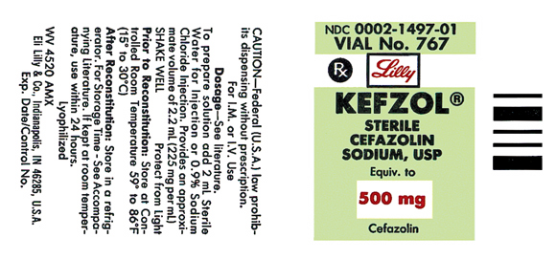

Here is a clear label similar to the one questioned on the practice sheet that was too fuzzy to read.

The label says:

Your Reconstitution fluid is “**add 2 mL**”

So you would draw up **2 mL** of the sterile fluid in the syringe to inject into the vial to reconstitute the powder

So, with the “powder portion + the 2 mL of sterile solution” added together, it brings the total volume in that vial to **2.2 mL**

After it is reconstituted, if you were going to want the full 500mg you would need to draw up the **2.2 mL** to have the full dose of 500 mg

The concentration is (**225 mg per mL**), remember usually found in the parenthesis.

HOWEVER, the label states “provides an approximate volume of 2.2 mL (225 mg per mL) and I do understand that **2.2 x 225 mg= 495** mg and not 500, that is why it says “approximate”.

Therefore, if you want to give 500 mg you would draw up the entire 2.2 mL in your syringe for the closest possible dose to 500 mg.

If you were asked to give a different dose ex: 250, when figuring out the desired over have times the quantity, the number you would plug in would look like this:

250 mg

______ X 1/mL

225 mg you must always plug in the **concentration** that the vial gives you