Medication Calculation 4 Worksheet

1 - 5. Order: Cefazolin 450 mg IV PB in 100 mL of 0.9% Normal Saline to run in over 1 hour.

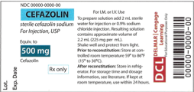

1. Indicate by an arrow the amount needed of sterile water to reconstitute on syringe.

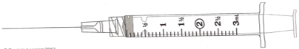

2. For a concentration of __________ mg/mL.

3. Indicate by an arrow the amount of reconstituted solution to be injected into 0.9% Normal Saline 50 mL IV bag.



4. Settings on pump:

Volume: _________ mL

5. Rate: _________ mL/h

6 - 10. Order: cytarabine 350 mg IV PB x 7 days in 100 mL of 0.9% NS to run in over 45 minutes.

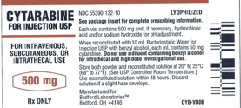

6. Indicate by an arrow the amount needed of Bacteriostatic Water for Injection to reconstitute on syringe.

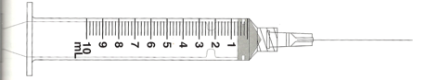

7. For a concentration of ___________ mg/mL

8. Indicate by an arrow the amount of reconstituted solution to be injected into 100 mL of 0.9% NS IV bag.



9. Settings on pump:

Volume: ___________ mL

10. Rate: _____________ mL/h

11 – 15. Order: Cetriaxone 800 mg IV PB of 50 mL of 0.9% NS over 30 minutes q12 h.

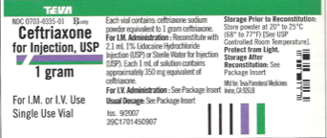

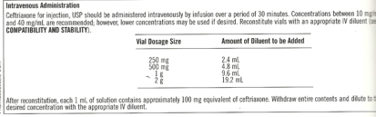

11. Indicate by an arrow the amount needed of Sterile Water for injection to reconstitute on syringe.



12. For a concentration of ____________ mg/mL.

13. Indicate by an arrow the amount of reconstituted solution to be injected into 50 mL IV bag.



14. Settings on pump:

Volume: _________ mL

15. Rate: __________ mL/h