Math Worksheet

1. A vial of ampicillin 500 mg is reconstituted with 4.5 mL sterile water to a dilution of 250mg/ mL. The patient is to receive 450 mg q 12 hours. How many mLs will be administered per dose?

___________________________________

1. How many mLs of medication will be drawn up from a vial labeled famotidine 20mg/2mL to administer 15 mg of the medication?

____________________________________

1. The nurse practitioner ordered that the patient is to receive adrenalin 0.7 mg subcut STAT. The medication is available in a vial labeled Adrenalin 2 mg/mL. How many mLs will be drawn up?

___________________________

1. The order is for Vamcomycin 750 mg IV to infuse over 45 minutes q8h. Vancomycin is available 750 mg/100 mL 0.9% Normal Saline.

At what rate would the nurse set the IV pump to deliver how many mL/hour to administer this medication?

______________________

1. The patient takes Amoxicillin 10 mL q 8 hours. How many teaspoons does the patient take in 24 hours?

______________________

1. The physician ordered Depakane 350 mg. po q12 hours. The medication is available in a syrup as 250mg/5mL. How many mLs will the patient receive in a 24 hour period?

__________________________

1. The nurse is to administer 375 mcg po daily. The medication is available in 0.125 mg tablets. How many tablets will the nurse administer to the patient with each dose?

___________________________

1. At what rate would the nurse set the IV infusion pump if the physician ordered the patient to receive 2000 mL of Lactated Ringers IV over 15 hours?

___________________________

1. Preoperatively, the patient is to receive 300 mcg IM 60 minutes prior to surgery. The medication is available as 0.2 mg /mL.

How much medication will the nurse draw up into the syringe to be administered?

_____________________________

**Questions #10 – 12 apply to the following scenario.**

1. The physician ordered the patient to receive an IV of 1000 mL of 0.9%NS with 125 mg of Aminophylline to infuse at 125 mL per hour.

A 10 mL vial of Aminophylline (250 mg /10mLs) at a concentration of 25mg/mL is to be used. How many mLs of Aminophylline will be added to the 1000 mL solution?

_________________________

1. The intravenous tubing has a drip factor of 15 gtts /mL. What would the nurse set the minute drop rate required to infuse the solution at 125 mL/hour?

_________________________

1. How many mg of Aminophylline will the patient receive intravenously per hour?

__________________________

Use ratio proportion

1000 mL/125mg =125mL/X

****************************************************************************************************

1. Vancomycin 2 gm/200mL is to infuse over 2 hours. It is to be infused via saline lock with a primary tubing having a drop factor of 60 gtts/mL. What would be the drip rate per minute to infuse this at the prescribed time?

____________________

14. Order: verapamil hydrochloride SR 240 mg po daily.

How many caplets would you give?

(Hint: read label 240 mg=1 caplet🡫) 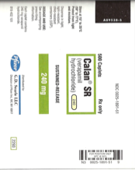

__________________________

15. The endocrinologist prescribed levothyroxine 50 mcg, PO daily.

How many tablet(s) would you give?

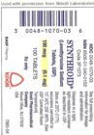

__________________________

16. The patient is to receive carbanazephine 300 mg po TID. How many pills will the patient receive with each dose?

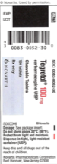

_____________________

17. The physician prescribed KCl 20 mEq po daily

How many tablets would you give?

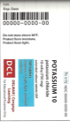

____ ________________

18. The nurse practitoner prescribed Cefaclor 375 mg. po q 12 hours. The patient will receive how many mLs in a 24 hour period?

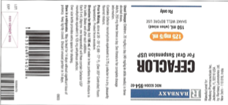

(175 mg/5mL)

__________________________

19. How many hours would be required to infuse 500 mL IV at a rate of 125mL/hr?

(Hint: divide total volume to be infused over hourly rate.)

_______________________

20. An intravenous order of 1000 mL of Lactated Ringers is to infuse at 125 mL/hr is initiated at 6AM. What time should the infusion end?

_______________________________

21. A 100 mL antibiotic solution must infuse IVPB over 45 minutes. The secondary tubing drop rate is 15 gtts/mL. What would the drip rate per minute to infuse this in the prescribed time?

________________________________