Nursing 175 Worksheet

Medication Calculation 2

1. The physician ordered Inderal 120 mg po daily. How many capsules would the nurse administer?

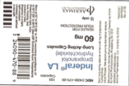

________________________

2. The physician ordered Lopressor 100 mg daily BID. How many tablets would the nurse administer for the 8 am dose?

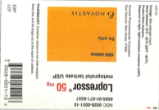

______________ _____________

3. The nurse practitioner ordered Ranitidine 300 mg po daily. How many tablets would the nurse administer for one dose?

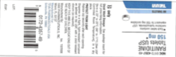

_____________________

4. The family nurse practitioner ordered Cefaclor 375 mg po q12 h x 7 days. How many mLs would the nurse administer for one dose?

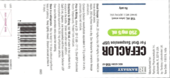

250/5 mL ______________

5. The surgeon ordered Vistaril 100 mg po at HS for insomnia, prn. The pt c/o “difficulty sleeping.” The nurse would give how many milliliters of Vistaril? 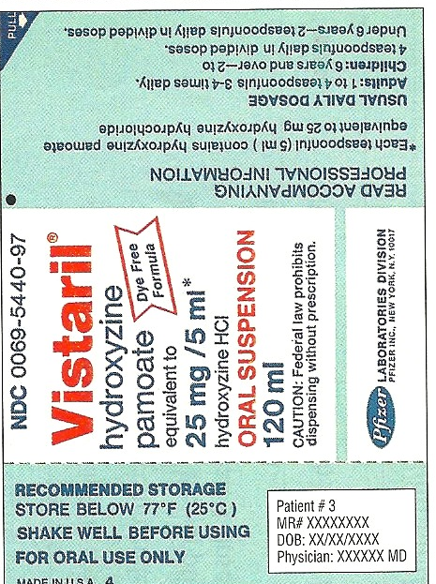

_____________________

6. The family nurse practitioner orders gentamycin 60 mg IM STAT. How much would the nurse administer?

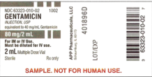

_______________________

7. The physician orders kanamycin 450 mg IV PB q8h. How much would you administer for a single dose?

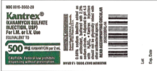

500 mg /2mL

___________________________

8. The cardiologist orders digoxin 0.125 mg IV q AM. How much would the nurse administer?

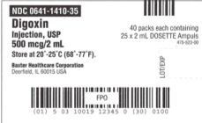

__________________

9. Convert 12:15 pm to international time. ___________________

10. Convert 8:49 pm to international time. ___________________

11. Convert 0001 to traditional time ____________________

12. Convert 2320 to traditional time _____________________

13. Convert 1:26 pm to military time _____________________

14. Convert “*zero hundred*” to traditional time ______________________